IFS Sales Configurator
Workshop

Class II: Rules
© 2000 IFS AB All Rights Reserved

Objective
To learn the basics of rule writing using the IFS Sales Configurator Workshop authoring tool. Attendees will be introduced to all aspects of rule-writing syntax as it applies to implementing solutions not handled by the core functionality of the IFS Sales Configurator programs. Following this class, attendees will be able to implement solutions involving complex data modeling requirements at customer sites.

Agenda

Part One
1. Introduction to basic rule writing concepts.
2. System objects and variables.
3. System functions.
4. Working with array variables, filters, and templates.
5. Additional concepts: Toolbar buttons and debugging.

Part Two
6. Baseline rules distributed to all new installations.
7. Review of several “How To” solutions.

Part Three
8. Internal Screens subsystem.
9. Page Design subsystem

Contents
PART I 1

Lesson 1: Introduction to Rule Writing Concepts 1
Rules 1
Rule Descriptions 2
Operate 2
Product Rules 3
Attach 3
Detach 3
Available 3
UnAvailable 3
Filter 3
Order 3
Reject Item 3
Variable Rules 4
Array 4
Define Local Var 4
Set 4
System Rules 4
Break 4
Call Task 4
Call Template 4
Exit 4
Message 5
OpenIntScreen 5
Remark 5
Visible 5
Output Rules 6
Document 6
Form 6
Table 7
MES 7
Screen Events Rules 7
Field Disable 7
Field Input 7
Field Output 7
File Rules 7
File 7
FileInput 8
FileOutput 8
Exercise One: Using the Rules grid 8
Return Value 8
Parameter Dialog Box 9
Variables 10
Contacts 10
Groups 10
Types 10
Products 10
Screens 11
Functions 11
Forms 11
Tables 11
Tasks 11
Globals 11
Templates 11
Templates Variables 11
Page Design Fields 11
Exercise Two: Using the Parameters dialog box 12

Lesson 2: System Level Objects and Variables 13
Special System Objects 13
$OPTION.criteria 13
$CONF.criteria 13
Exercise Three: Using $OPTION and $CONF 14
System-Defined Variables 15
$id 15
$name 15
$desc 15
$quantity 15
$belong 15
$type 16
$remarks 16
$reserved 16
$unit 16
$warnings 16
User-Defined Variables 16
System Globals 18
Product Globals 18
$CurrentBOMID 18
$CurrentOptionID 18
$CurrentMainItem 18
$CurrentConfItem 18
$CurrentOptionItem 18
$FirstConfID 19
$FirstOptionID 19
$LastConfID 19
$LastOptionID 19
System Globals 19
$ConfFileName 19
$CurrencyName 19
$CurrencyRate 19
$CurrencySymbol 19
$CurrentEvent 19
$CurrentGroup 19
$CurrentTask 20
$CurrentType 20
$Profile 20
$ProposalFileName 20
$TotalPrice 20
$UpdateColumn 20
$UserName 20
$Version 20
Special Function System Globals 21
$Field 21
$Template 21
Exercise Four: Referencing the correct object with System Globals 21

Lesson 3: System Functions 22
System-Defined Functions 22
Item ID Functions 22
$GetConfID(expression) 22
$GetOptionID(expression) 22
$NextConfID(currentid) 22
$NextOptionID(currentid) 22
$PrevConfID(currentid) 23
$PrevOptionID(currentid) 23
Filter Functions 23
$FirstFilterID(filtername) 23
$NextFilterID(filtername,currentid) 23
$PrevFilterID(filtername,currentid) 23
System Functions 23
$GroupItems(groupname) 23
$InGroup(groupname) 23
$InType(typename) 24
$IsAvailable(name/id) 24
$ItemConfExists(id) 24
$ItemOptionExists(id) 24
Variable Functions 24
$ArrayEntries(arrayvariable) 24
$ScrnVar(varname) 24
Exercise Five: $ScrnVar 25
$StringToVar(varname,varstring) 25
$Var(varname) 25
$VarExists(varname) 25
$VarToString(varname,picturestring) 25
Mathematical Functions 26
General 26
$ABS(number) 26
$Degrees(radians) 26
$E() 26
$EXP(number) 26
$Fact(number) 26
$Ln(number) 27
$LOG(number) 27
$LOG10(number) 27
$Mod(number,divisor) 27
$PI() 27
$Power(number,power) 27
$POW10(number) 27
$Radians(degrees) 27
$Rand() 27
$Round(number,numdigits) 27
$Sign(number) 27
$SQR(number) 28
$SQRT(number) 28
$Trunc(number,numdigits) 28
Conversion 28
$CDbl(text/number) 28
$CInt(text/number) 28
$CLng(text/number) 28
$CStr(number) 28
Trigonometry 28
$ACOS(number) 28
$ASIN(number) 28
$ATAN(number) 28
$COS(number) 29
$COSH(number) 29
$SIN(number) 29
$SINH(number) 29
$TAN(number) 29
$TANH(number) 29
Text Functions 30
General 30
$Len(text) 30
$Char(ASCIIcode) 30
$Concatenate(string1,string2) 30
$Fixed(number,decimal,commas) 31
$Trim(text) 31
$Value(text) 31
Sub-string 31
$Left(text,numchars) 31
$Mid(text,startposition,numchars) 31
$Right(text,numchars) 31
Case 31
$Lower(text) 31
$Proper(text) 31
$Upper(text) 31
Searching 32
$Find(findtext,withintext,startnumber) 32
$Replace(oldtext,startposition,numchars,newtext) 32
$Search(findtext,withintext,startnumber) 32
Exercise Six: Complex String Expressions 32
Date & Time Functions 33
General 33
$Now() 33
$Today() 33
$Weekday(date,returntype) 33
Date 34
$Date(year,month,day) 34
$Day(date) 34
$Month(date) 34
$Year(date) 34
Time 34
$Time(hour,minute,second) 34
$Hour(date) 34
$Minute(date) 34
$Second(date) 34
Statistical Functions 35
$Min(number1,number2) 35
$Max(number1,number2) 35

Lesson 4: Arrays, Loops, Filters, and Templates 36
Arrays 36
Reading Array Values 36
Writing Array Values 36
Array Uses 36
Exercise Seven: Using Arrays 38
Loops 39
Break 39
Operate While 39
Operate BOM 39
Operate Options 39
Operate CMI 39
Exercise Eight: Using Nested Loops 40
Filters 41
Defining a filter 41
Sorting a filter 41
Managing the pointer to the current product in the filter 41
Template Variables 43

Lesson 5: Additional Concepts 44
Toolbar Buttons 44
Tools.dll 44
Tools.ini 44
Debugging Techniques 46
Messages 46
View All Rules tab 46
Find Rules 47
Logger 49
Variable Checker 50

PART II 51

Lesson 6: Baseline Rules distributed to all new installations 51
Pricing 51
Option Dependencies 51
Order Validation 51
File Tasks 51
Order Tasks 51
Pricing Tasks 51
Proposal Tasks 51
Report Tasks 52

Lesson 7: How To Examples 53
Capacity Limits 54
Filter 57
Keyboard Versus Drag & Drop Item Entry 59
Selecting Alternative Languages 62
Language Selection Screen 63
Setting the language when inserting items to a configuration: 63
Select Language Tool: 63
Change Selected Language Tool: 64
Using the alternative language in output documents: 64
Multiple Qty Adds 65
SetOptionQuantities Task 65
Order File Creation 67
Special Customer Request (SCR) Parts and IFS Integration 68
AddScr Task 69
ValidateSCR Task 69
Stand Alone Options 71

PART III 73

Lesson 8: Screen Design Section 73
Screen Generation process 73

Lesson 9: Page Design Section 78
Specifying the HTML page location 78
Defining section fields 79

APPENDIX A: ASCII Codes 81
APPENDIX B: Exercises 82
Exercise One: Using the Rules grid 82
Exercise Two: Using the Parameters dialog box 84
Exercise Three: Using $OPTION and $CONF 85
Exercise Four: Referencing the correct object with System Globals 86
Exercise Five: $ScrnVar 87
Exercise Six: Using Arrays 88
Exercise Seven: Complex String Expressions 89
Exercise Eight: Using Nested Loops 90

PART I

Lesson 1: Introduction to Rule Writing Concepts

Rules

OBJECTIVE: To understand how to create complex tools and procedures using the rules in the system. These can be used to manipulate data objects and variables, filter or change items in the configuration, control rule execution, generate output, and display screens requesting user input.

Rules are the primary way to control the operation of IFS Sales Configurator. They provide programmatic control of virtually any object in the system. Rules are written in a programming grid that resembles a spreadsheet. You are prompted for the appropriate parameters for each statement by the column headings that change depending on the rule you are writing.

Rules can be written in numerous places within IFS Sales Configurator Workshop:

Product-Related Subsystems: Groups, Product Types, and Products. A Rules tab provides a separate programming grid for Insert, Delete, and Update rules.
- Insert rules are fired (executed) when an associated product is added to a configuration.
- Delete rules fire when an associated product is removed from the configuration.
- Update rules run when the user changes a configuration product attribute.
When an item is inserted into a configuration, the rules are executed in the following order:
- Group rules run before the item is inserted into the configuration.
- Product Type rules run after the item is inserted into the configuration.
- Product rules run after Product Type rules run.

Tasks Subsystem: The Tasks subsystem allows you to organize your code in manageable folders, create tools that are directly accessible from the menu system of IFS Sales Configurator, and create blocks of code as routines that can be used as necessary. Rules written in the Tasks subsystem are not executed until they are invoked.

Tools are invoked by the user clicking on a tool listed on the Tools menu of IFS Sales Configurator. Routines are invoked by using the Call Task rule and specifying the name of the routine.
Document Generating Subsystems: Proposal Generator, Report Generator, and Order Entry. These subsystems allow you to create templates for generating various forms of output from the system. A Rules tab appears in the right pane when any template is selected in the left pane.

A template created in these subsystems will appear in the menu system for IFS Sales Configurator as selections on the Proposals, Reports, and Order-Entry menus, respectively. When the user invokes these templates by clicking on the menu item, the rules written for that template run.

Rule Descriptions
The following descriptions cover all the rules available in IFS Sales Configurator Workshop. See Online Help for detailed descriptions including syntax, arguments, and remarks.

Operate
The Operate rule is used to separate blocks of code and to create loops. All rules must be written after an Operate rule. The Operate rule always has a Type argument, where you can choose Always, While, BOM (Bill of Materials, the right side in IFS Sales Configurator), CMI (Current Main Item), or Options (Options List, the left side in IFS Sales Configurator). Operate: Always will be discussed here. For descriptions of the other types of Operate rules, see the Loops section on page 39.

Operate rules remain in effect until the next Operate rule or the end of the routine or task. Operate: Always executes the rules below it in a top to bottom order once each time the task or routine is invoked. The Condition column allows you to apply a condition expression to the entire block of code. If the condition evaluates to FALSE, rules in the Operate: Always loop are skipped and execution continues at the next Operate rule, if it exists. If there is not another Operate rule, the code terminates. If the routine was called from a Call Task rule in another block of code, control returns to the calling rule.

Product Rules

Attach
Adds the specified item to a configuration. The Attach rule has a similar function to the Attachments tab in the Groups and Products subsystems.

Detach
Removes the specified product(s) from a configuration.

Available
Designates the specified item or items as available for selection into a configuration for the current Main Item.

UnAvailable
Designates the specified item as unavailable for insertion into a configuration under the currently selected Main Item. The item's availability under other Main Items in the configuration depends on the relationship defined in IFS Sales Configurator Workshop. The UnAvailable rule applies only to the selected Main Item.

Filter
Filters a given set of items according to specified criteria. Filter criteria can include variable values or any other expressions. Use the special system objects $OPTION and $CONF to include multiple product Ids in the filter. You access the items that have been filtered with the $FirstFilterID, $NextFilterID, and $PrevFilterID functions.

Order
Sorts the list of items generated by a Filter rule according to one of the product attributes. Up to three levels of sorting can be done with the Order rule.

Reject Item
Used only in Group rules, stops an item from being inserted into the configuration based on the condition in the Condition column.

Variable Rules

Array
Use the Array rule to manipulate array-type variables. The rule adds, deletes, and updates array entries. For a complete discussion of Array variables, see page 36.

Define Local Var
Creates a local variable in one of the Sales Configurator Data Types. A local variable is valid from the line that defined it until the end of the set of rules. If you branch to another set of rules with the Call Task rule, the local variable will not be valid in the called task.

Set
Used to assign values to variables.

System Rules

Break
Stops the running of an Operate loop when the Condition argument is satisfied. Execution will continue with the next Operate loop if one exists. To stop running of the entire task, use the Exit rule.

Use the Break rule to increase the performance of tasks by stopping a loop once the desired results have been produced.

Call Task
Starts the task specified by the Task Name argument.

Call Template
Executes one of the pre-defined templates in IFS Sales Configurator Workshop and specifies the output to either the screen, a file, or both. The file must be in HTML format.

Exit
Stops the execution of a task or set of rules. To break out of only the current Operate loop and not the entire task or set of rules, use the Break rule.

Message
Generates a message box that displays the specified text. The text can be any string or concatenation of strings using the plus (+) character as the concatenation character. User messages should be as informative as possible. For instance, the following messages illustrate the difference in the usefulness of the message when you incorporate database information.

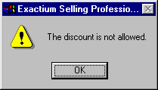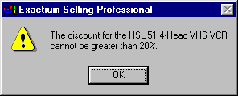

"The discount is not allowed." | "The discount for the " + $CurrentConfItem.$name + " " + $CurrentConfItem.$desc + " cannot be greater than " + $CStr($CurrentConfItem.Discount_Limit) + "%."

Messages used in debugging can also return variables other than strings, but all elements of the message must be the same data type. This allows you to check the value of a variable with a simple message box inserted at the proper point in the code.

OpenIntScreen
Opens a screen designed in the Screen Generator subsystem as a dialog box with OK and Cancel buttons. The button clicked by the user is accessible by entering a variable in the Return Val column.

- If the variable is a number, clicking OK stores a 1 and clicking Cancel stores a 0.
- If the variable is a string, clicking OK stores "OK" and clicking Cancel stores "Cancel".

Remark
Allows you to add comments to your code.

Visible
Designates an item as visible or invisible for IFS Sales Configurator end-users in the Bill of Materials and for templates (Proposals, Reports and Order Entry) generated with the Auto Action. You can use the visible rule to hide items in the Bill of Materials that should not be visible to the user as products, such as Terms and Conditions, or legal text.

Note:
- For Tools created in the Tasks subsystem, you can specify a keyboard shortcut by placing an ampersand(&) directly in front of the character you would like to be the shortcut. The user can invoke a custom tool by selecting the Tools menu with the ALT+T key combination, then selecting the desired tool by pressing the letter of the tool name that is underlined, which is the character following the ampersand in the description defined in the Tasks subsystem. If more than one tool has the same letter underlined (preceded by an '&'), then the selection will toggle between all tools with that designated letter. The user presses Enter when the selection is on the desired tool.

Output Rules
The Return Val column for Document, Form, and Table rules allows you to monitor the success of the rule. If the document is created successfully, the value of the number variable you enter into the Return Val column will be 1. If the referenced HTML documents can't be found, the creation will fail and the value of the Return Val variable will be 0. You can use this information to handle the error and present a message to the user.

Document
Embeds a static HTML page that does not include any variables—it does not contain any information extracted from the database—into a Proposal, Order Entry, or Report template. The Document rule can only be used in the rules of the three template subsystems: Proposal Generator, Report Generator, and Order Entry.

Form
Fills information from the database in one of the sections defined in the Page Design subsystem.
The Form rule can only be used in the context of IFS Sales Configurator Workshop template subsystems—Proposal Generator, Report Generator, and Order Entry. The Form rule may be used in the Tasks subsystem as long as the task is called from a Call Task rule in one of the template subsystems.

Table
Generates a table defined in the Page Design subsystem. A Table rule outputs a HTML table with as many rows as necessary for its data source. You can only use the Table rule in context of IFS Sales Configurator Workshop template systems—Proposals, Reports, and Order Entry rules.
The HTML file used for the Page Design must contain an HTML table definition with the following three rows defined:
- Header Row (Required) - contains static header text for each column in the table
- Body Row (Required) - contains field names for each column that will be filled with configuration data each time the Table rule is called with the Table Body action. Field names are designated in HTML using the square brackets and # sign, such as [#DESCRIP] or [#EXTENDEDPRICE]
- Footer Row (Optional) - contains static text and/or field names, such as totals or summaries

MES
Embeds a Marketing Encyclopedia System (MES) HTML document into a template— Proposal, Order Entry, or Report. The MES HTML documents are linked to MES variables and are compressed when you create a version. The MES rule extracts those files and embeds them into a proposal.
Screen Events Rules

Field Disable
A Boolean that either disables (grays out) or restores and enables a combo box or edit box in a screen. Use the Field Disable rule in Screen Events tasks.

Field Input
Places a value in an edit box or combo box. Use this rule in conjunction with Screen Events.

Field Output
Allows a user to transfer the value in either a combo box or edit box to a variable in the system. Use this rule in conjunction with Screen Events.
File Rules

File
Creates, opens, or closes a disk file. Use the File rule with the FileInput rule and the FileOutput rule to communicate with other applications and store data in disk files.

FileInput
Reads data from a disk file opened with the File rule. You can read a specific number of characters of data, or all data up to a common delimiter.

FileOutput
Writes data into disk files opened with the File rule in text or binary modes.

Exercise One: Using the Rules grid

Return Value
Return Val is an argument for Document, Form, Table, and OpenIntScreen rules that allows you to monitor the success of the action being performed.

By entering a number variable in the Return Val column, you can then check the success of the generation of a document, form, or table. If the generation was successful, the variable will be set to 1. If it failed, such as when the document can't be found, the variable will be set to 0.

You can also check the button the user clicked to close an internal screen. All internal screens have an OK and a Cancel button. You can enter a number or string variable in the Return Val column. If Return Val contains a number variable and the user clicked OK, the variable will be set to 1. If the user clicked Cancel, the variable will be set to 0. If Return Val contains a string variable and the user clicked OK, the variable will be set to "OK". If the user clicked Cancel, the variable will be set to "Cancel".

You use the internal screen Return Value as a condition to exit or break out of the screen's function if the user clicked Cancel.
Operate | Always
 | OpenIntScreen | ScreenName | $Global.RetVal
 | Exit | $Global.RetVal = "Cancel"

Parameter Dialog Box
OBJECTIVE: To use the Parameter Dialog Box to build expressions and conditions to accurately add references to system objects, products, functions, and variables.

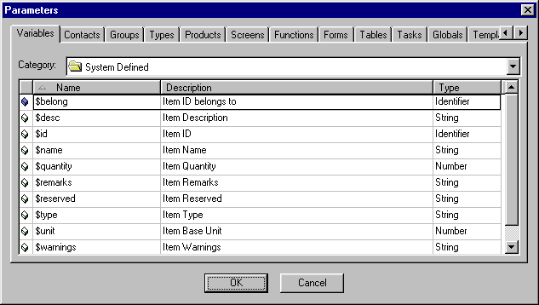

When you double-click in any expression or condition cell, a folder button appears at the far right of the cell. Click this button to open the Expression dialog box, which allows you to see many more characters of code than are visible in the cell.

Click the Parameters… button to display the Parameters dialog box. The object you select in the Parameters dialog box will be inserted at the cursor in the Expression dialog box. (If an expression is already in the rule cell, it will be selected in the Expression dialog box when it is opened. If you leave the existing expression selected, it will be overwritten by your selection from the Parameters dialog box. If you do not want the selection to be overwritten, click to move the cursor to where you would like the Parameters object to be inserted.

The following box will provide the location in the Parameters dialog box for the objects referenced in this course guide.

Parameters dialog box | Tab: | < tab name > | Category: | < category >

Variables
Provides access to all variables defined throughout the system, including System Defined, Global, Configuration, Guided Questions, Pricing, MES, and Template.

Contacts
Provides access to Contact variables linked from the Windows Address Book or a MAPI Address Book, such as the address book used by Outlook or other mail clients. The user decides which address book to use in the Properties box on the File menu.

Before creating output that includes contact information, the user should pick the contact to associate to the configuration by using the Select Contact command from the Proposals menu. You can use the contact variables to populate fields in a template, and the values of those fields will automatically come from the users address book.

Groups
Provides access to the names of all the groups defined in the Groups subsystem. A drop-down list lets you choose to see All groups, or only those from a specific Group Category.

Types
Provides access to the names of all the product types defined in the Product Types subsystem.

Products
Provides access to all products defined in the Products subsystem. A Category drop-down list lets you select the product type for which you would like to view products. Changing the value of the Category field displays all items in the product type you select. Select the desired product and click OK to insert the product's name into the expression.

The drop-down list also has an entry for the system-defined globals that are used to hold the value of product identifiers under different circumstances. For a description of these system-defined globals, see the System Globals Section on page 18.

Screens
Provides a list of all screens that have been defined in the Screen Generator subsystem.

Functions
Provides access to all functions available in the system. A drop-down list lets you select All functions, or a specific category such as System-Defined, Mathematical, Date & Time, Statistical, and Text. Descriptions for all functions are in the Functions Section on page 22.

Forms
Provides a list of all sections, defined as type Form, that have been created in the Page Design subsystem.

Tables
Provides a list of all sections, defined as type Table, that have been created in the Page Design subsystem.

Tasks
Provides access to the names of all tasks that have been written in the Tasks subsystem. A drop-down list lets you see All tasks, just Tools, or just Routines.

Globals
Provides access to all of the system globals. Descriptions of each can be found in the System Globals Section on page 18.

Templates
Provides access to the templates that have been created in the Proposal Generator, Report Generator, and Order Entry subsystems.

Templates Variables
Provides access to the variables associated to templates that have been created in the Proposal Generator, Report Generator, and Order Entry subsystems. Templates variables are created on the Variables tab in the right pane of each of these subsystems.

Page Design Fields
Provides access to all data field tag names that have been defined in the source HTML used to create sections in the Page Design subsystem. When the HTML code used as a section contains a name with the field syntax, [#fieldname], that field is automatically added to the Fields tab in the right pane of Page Design and is accessible through this tab of the Parameters… dialog box.

Note:
- Condition statements always evaluate to TRUE(1) or FALSE(0). The rule is executed only if the condition is TRUE.
- You can put multiple conditions in a condition statement using the AND and OR logical operators. Statements are evaluated from left to right and parentheses are ignored.

- TRUE AND TRUE IS TRUE
- TRUE AND FALSE IS FALSE
- FALSE AND TRUE IS FALSE
- FALSE AND FALSE IS FALSE
- TRUE OR TRUE IS TRUE
- TRUE OR FALSE IS TRUE
- FALSE OR TRUE IS TRUE
- FALSE OR FALSE IS FALSE

Exercise Two: Using the Parameters dialog box

Lesson 2: System Level Objects and Variables

Special System Objects
OBJECTIVE: To use the $OPTION and $CONF system objects in the correct context and syntax to reference multiple products simultaneously.

Two system objects operate in a special way that make them extremely powerful for writing expressions and conditions. When used properly, these objects allow you to access multiple products with a single expression, without the need to create a loop. $OPTION references product options from the catalog on the left side of the Configurator. $CONF references products that have already been added to the current configuration (right side of the Configurator).

Parameters dialog box |  | Not Available

$OPTION.criteria
Use in the Expression column of Attach, Available, Detach, Filter, and Unavailable rules, or in Expression columns in subsystem screens. $OPTION returns all products from the Options list that matches the criteria you specify. The criteria can be any expression that returns TRUE or FALSE for every product in the Options list, including Boolean functions such as $Option.$InGroup("groupname") and $Option.$IsAvailable("partname"). You can also specify a value or range for product variables, such as $OPTION.Color="Red" or $OPTION.Price>=1000.

$CONF.criteria
$CONF is used in a similar manner to $OPTION, except the products are returned from the current configuration (the right side of IFS Sales Configurator), instead of the Options list. If the criteria is TRUE for a product, it is returned by $CONF. All products in the configuration are evaluated.

Note:
- Use $OPTION in the Options column on the Screen Generator Input tab to fill in choices in a combo box with the product's description. $OPTION.Price > 500.

Exercise Three: Using $OPTION and $CONF

System-Defined Variables
OBJECTIVE: To recognize and use the system-defined variables assigned to each product.

The system provides certain variables for each product, some set by the system, some set by the administrator, and some by system rules. System-defined variables can be used for any product in the same way that you use user-defined variables.

Parameters dialog box | Tab: | Variables | Category: | System Defined

$id
Read-only. Identifies a particular item in a configuration. Although $name is unique for each item in the Options area, the same item may appear more than once in a configuration. Each instance will have its own associated value for the $id variable.
Note: The value for $id is different for an item in the Option List and in a configuration.

$name
Read-only. Each item that appears in the Options area in the IFS Sales Configurator must have a unique name that is stored in the $name variable.

$desc
A string value that holds the description of an item, as defined in IFS Sales Configurator Workshop.

$quantity
Holds an iitem’s quantity. An item's quantity may be different in a configuration than in the Options List.

$belong
Read-only. Holds an IFS Sales Configurator product object ID representing a Main Item. Each option product in a configuration is associated with a Main Item when an end-user selects it into a configuration. The Main Item Object Identifier is stored for each item in its $belong variable. The $belong variable is valid only for products in a configuration. The $belong variable for a Main Item is the ID of the Main Item.

$type
A string representing the type of insertion that added the item to the configuration. This variable is set by the system. The possible values are Normal, Required, Special Add, or User-Supplied Add.

$remarks
A pre-defined string variable holding remarks about an item, according to the application needs.

$reserved
A pre-defined string variable that holds reserved information about an item according to the application needs.

$unit
Read-only. Stores the base unit in which the item is supplied.

$warnings
Holds a string representing the system-generated warning that appears when an Enable Group constraint is breached and the "To do.." action setting is "Add to Alarms."

User-Defined Variables
OBJECTIVE: To be able to create and reference variables that hold data for use in expressions and conditions according to the application needs.

You can create user defined variables for use in your application code. Variables may be created for global use, product specific use, or use within a task or set of rules.

Global variables are created at the application level and can be used anywhere in Workshop. Each variable holds a single value (or array of values) for the application. Create Global variables at the Product Types level of the Product Types subsystem tree. Global variables are referenced with the $Global qualifier, such as $Global.RetVal. When selected from the Parameters dialog box, the "$Global" qualifier will be added to the variable name automatically.

Product variables hold a single value (or array of values) for each product for which they are defined. Create Product variables at the appropriate level of the Product Types tree in the Product Types subsystem. All products defined at that level or in any sub-levels will have that variable available to it. Product variables are referenced with the ID of the product. Generally, the system globals defined in the next section are used to reference the product ID, such as $CurrentConfItem.Price.

Parameters dialog box | Tab: | Variables | Category: | Global  Configuration  Guided Questions  Pricing  MES  Template

Local variables are created with the Define Local Var rule and can be used only within the task or set of rules where they are declared. If you call a different task with the Call Task rule, the local variable will not be available in the called task. Local variables are referenced with the $Local qualifier, such as $Local.Counter.

Since Local variables are not available in the Parameters dialog box, they must be typed manually.

Parameters dialog box |  | Not Available

System Globals
OBJECTIVE: To be able to reference objects and system information with the system-defined Globals.

System Globals allow you to reference products and system information. The product globals return a product identifier. Product identifier variables followed by the dot (.) operator can then reference any attribute of the product after the dot, such as a variable or function.
Parameters dialog box | Tab: | Globals | Category: | All
Product Globals

$CurrentBOMID
Holds the current product object in the Bill of Materials (Configuration) within an Operate BOM or Operate CMI loop. The rules in an Operate BOM loop in a rule will be performed for each item in the current Bill of Materials. The $CurrentBOMID allows you to reference the current item in any expressions or conditions.

$CurrentOptionID
Holds the current product object in the Options List in an Operate Options loop.

$CurrentMainItem
Holds a product identifier representing the currently selected Main Item. The current Main Item can be specified by a IFS Sales Configurator user or by setting the value of $CurrentMainItem. If an option attached to a Main Item is the currently selected item, the identifier of its associated Main Item is held in $CurrentMainItem.

$CurrentConfItem
Holds the current product object in the Bill of Materials (Configuration). The $CurrentConfItem value is the product that has the input focus on the Configuration side (right side) of IFS Sales Configurator.

$CurrentOptionItem
Holds the current product object in the Options List. The $CurrentOptionItem value is the product that has the input focus in IFS Sales Configurator.

$FirstConfID
Holds a product object representing the first configuration product in the currently open configuration.

$FirstOptionID
Holds a product object representing the first Options List product.

$LastConfID
Holds a product object representing the last configuration product in the currently open configuration.

$LastOptionID
Holds a product object representing the last Options List product.

System Globals

$ConfFileName
A string containing the name of the currently open configuration file.

$CurrencyName
Contains the name of the currently selected currency.

$CurrencyRate
A number representing the exchange rate of the current currency.

$CurrencySymbol
A string representing the symbol and format for the currently selected currency, such as
"$-9,999.2".

$CurrentEvent
Contains a number representing the current event where rules or tools run. If invoked by an Insert rule, $CurrentEvent returns zero (0). Delete rules return 1, Update rules return 2, and Tools return 3.

$CurrentGroup
Used in Group rules, returns the name of the current group.

$CurrentTask
Returns the name of the current task being run. $CurrentTask returns an empty string if used outside of the Tasks subsystem.

$CurrentType
Contains the name of the Product Type while running a Product Type rule.

$Profile
Contains the name of the current profile.

$ProposalFileName
A string containing the name of the last generated proposal.

$TotalPrice
A currency value equaling the rule-generated total price for a configuration. $TotalPrice is not calculated automatically; you must include Set statements that change the value of $TotalPrice when it is affected.

If the user selects “Display Total Price” on the List View Fields tab of the User Properties window in IFS Sales Configurator, this is the variable displayed as the Total Price below the configuration pane.

$UpdateColumn
Contains the name of the variable associated with the last updated column in the Bill of Materials list view (right pane) of the IFS Sales Configurator. Use $UpdateColumn to check if a change was made to a variable that requires some kind of recalculation.

$UserName
A string holding the name of the user logged in to the IFS Sales Configurator.

$Version
Holds the version number of the IFS Sales Configurator.

Special Function System Globals

$Field
Holds an object representing the input fields on a currently open user-defined screen. $Field should be followed by the dot operator and the input field's name.

$Template
Designates variables created in the Proposal Generator, Report Generator, and Order Entry subsystems.

Note:
- The identifier of a product in the configuration is different than its identifier in the Options list. Items are assigned identifiers as they are added to a configuration, and they will not necessarily be listed in the same order that they are displayed in IFS Sales Configurator.

Exercise Four: Referencing the correct object with System Globals

Lesson 3: System Functions

System-Defined Functions
OBJECTIVE: To be able to use the system-defined functions to create powerful expressions, conditions, and loops.

IFS Sales Configurator Workshop uses numerous built-in functions for use in expressions, conditions, and system fields. Descriptions are given here. See online Help for detailed descriptions including syntax, arguments, and remarks.

The argument in parentheses is indicated for each function with the type of argument required for the function. You may use literal values or variables that have been defined as that data type.

Parameters dialog box | Tab: | Functions | Category: | System Defined

Item ID Functions

$GetConfID(expression)
Searches for a product in the configuration that satisfies the expression argument. If the specified product is found within the list of selected products, $GetConfID returns its identifier. The expression can be a product name string, or a valid search criteria for a product.

$GetOptionID(expression)
Searches for an option product that satisfies the expression argument. If the specified product is found within the list of options, $GetOptionID returns its identifier value. The expression can be a product name string, or a valid search criteria for a product.

$NextConfID(currentid)
Returns the identifier value of the product in the configuration following the product represented by the currentid argument.

$NextOptionID(currentid)
Returns the identifier value of the product in the Options list following the product represented by the currentid argument.

$PrevConfID(currentid)
Returns the identifier value of the product in the configuration before the product is represented by the currentid argument.

$PrevOptionID(currentid)
Returns the identifier value of the product in the Options List before the product that is represented by the currentid argument.
Filter Functions

$FirstFilterID(filtername)
Returns the identifier value of the first product a filter finds.

$NextFilterID(filtername,currentid)
Returns the identifier value of the product in a filter following the product represented by the currentid argument. Used in a Filter loop to advance the pointer, or evaluation item, to the next ID for the next iteration of the loop.

$PrevFilterID(filtername,currentid)
Returns the identifier value of the product in a filter before the product that is represented by the currentid argument.
System Functions

$GroupItems(groupname)
Used only in Available, UnAvailable, Attach, Detach, and Filter rules. Returns all products that belong to the group in the groupname argument by directly referencing the group's members.

$InGroup(groupname)
Used in any expression or condition. Returns all products that belong to the group in the groupname argument by checking each Options list product for membership in the group.

Note:
- While the functionality of $GroupItems and $InGroup are very similar, $GroupItems can only be used in Available, UnAvailable, Attach, Detach, and Filter rules. $InGroup can be used in any expression or condition.
- The $InGroup function can be used in the Screen Generator subsystem to populate the options in a Combo box with the descriptions of items that belong to a group. On the Input tab of a screen with a combo box, enter an expression like $OPTION.$InGroup("Engines"). When the screen displays, the choices in the combo box will be the descriptions of all the items that belong to the Engines group. The expression $OPTION.$GroupItems("Engines") would fail to fill the combo box with descriptions because the $GroupItems function is allowed only in the expression cell of Available, UnAvailable, Attach, Detach, and Filter rules.

$InType(typename)
Returns True (1) if the specified item belongs to the Product Type specified in the argument.
Returns False (0) if the specified item does not belong to the Product Type specified in the argument.

$IsAvailable(name/id)
Returns True (1) if the product specified by the name/id argument is available for selection into the configuration for the current Main Item. The current Main Item is designated by a check box of the right side of the IFS Sales Configurator.

$ItemConfExists(name)
Returns True (1) if the product specified by the name argument exists in the configuration (the right side of the IFS Sales Configurator).

$ItemOptionExists(name)
Returns True (1) if the product specified by the name argument exists in the Options List (the left side of the IFS Sales Configurator).
Variable Functions

$ArrayEntries(arrayvariable)
Returns the number of entries in the specified array variable.
Note:
- In IFS Sales Configurator Workshop, the first entry in an array is element number 1.

$ScrnVar(varname)
Used in a Product Update rule to determine the value a user enters in an editable column on the right side of the IFS Sales Configurator. Note that the argument for $ScrnVar is the variable name, not the column heading. If the user profile is defined with a column called Quantity and the variable displayed in that column is $quantity, you would use "$quantity" as the argument for $ScrnVar, including the quotation marks.

Exercise Five: $ScrnVar

$StringToVar(varname,varstring)
Returns an IFS Sales Configurator Workshop variable in its original format from a picture-formatted string.

$Var(varname)
Returns the value of the IFS Sales Configurator Workshop variable specified by the name argument.

$VarExists(varname)
Returns a Boolean value to indicate whether the variable specified by the name argument exists for the referenced product.

$VarToString(varname,picturestring)
Returns a string representing the value of the variable specified by the varname argument. The string is formatted according to the picture specified in the picturestring argument.

Note:
- To easily format a picture string to use in $VarToString, go to the Default Pictures tab of the Properties dialog box on the File menu. Click the folder button next to the applicable format and make selections in the dialog box, then click OK. The picture field will contain the picture to match your selections, which you can copy and paste between quotation marks for the picturestring argument. Make sure to close the Properties dialog box with the Cancel button, unless you want to change your default picture.

Mathematical Functions
OBJECTIVE: To use system functions to perform mathematical calculations.

Standard mathematical operators are:
+ Addition (5 + 10 = 15)
- Subtraction (5 - 10 = -5)
* Multiplication (5 * 10 = 50)
/ Division (5 / 10 = 0.5)

IFS Sales Configurator Workshop's mathematical functions provide the powerful calculations of the most common arithmetic, trigonometric, and conversion functions.

Parameters dialog box | Tab: | Functions | Category: | Mathematical

General

$ABS(number)
Returns the absolute value of a number.

$Degrees(radians)
Converts radians into degrees.

$E()
Returns the e constant, equal to 2.71828182845904, the base of the natural logarithm.

$EXP(number)
Returns e raised to the power of number. The constant e equals 2.71828182845904, the base of the natural logarithm.

$Fact(number)
Returns the factorial of a number. The factorial of a number is equal to 1*2*3*...* number.

$Ln(number)
Returns the natural logarithm of a number. Natural logarithms are based on the constant e (2.71828182845904).

$LOG(number)
Returns the logarithm of a number to the base you specify.

$LOG10(number)
Returns the base-10 logarithm of a number.

$Mod(number,divisor)
Returns the remainder after number is divided by divisor. The result has the same sign as divisor. You can use the $Mod function to determine if a number is evenly divisible by divisor. If $Mod returns 0, number is evenly divisible by divisor.

$PI()
Returns the number 3.14159265358979, which is the mathematical constant pi.

$Power(number,power)
Returns the result of a number raised to a power.

$POW10(number)
Returns the result of a number raised to the power of ten (10).

$Radians(degrees)
Converts degrees to radians.

$Rand()
Returns an evenly distributed random number greater than or equal to zero (0) and less than one (1).

$Round(number,numdigits)
Rounds a number to a specified number of digits.

$Sign(number)
Determines the sign of a number.

$SQR(number)
Returns a number squared.

$SQRT(number)
Returns a positive square root.

$Trunc(number,numdigits)
Truncates a number to an integer by removing any fractional part.
Conversion

$CDbl(text/number)
Converts an expression to a double data type value.

$CInt(text/number)
Converts an expression to an integer data type value.

$CLng(text/number)
Converts an expression to a long integer data type value.

$CStr(number)
Converts a number to a string.
Trigonometry

$ACOS(number)
Returns the arccosine of a number. The arccosine is the angle whose cosine is number. The returned angle is given in radians ranging from zero (0) to pi (p).

$ASIN(number)
Returns the arcsine of a number. The arcsine is the angle whose sine is number. The returned angle is given in radians in the range -p/2 to p/2.

$ATAN(number)
Returns the arctangent of a number. The arctangent is the angle whose tangent is number. The returned angle is given in radians in the range -p/2 to p/2.

$COS(number)
Returns the cosine of the given angle.

$COSH(number)
Returns the hyperbolic cosine of a number.

$SIN(number)
Returns the sine of the given angle.

$SINH(number)
Returns the hyperbolic sine of a number.

$TAN(number)
Returns the tangent of a given angle.

$TANH(number)
Returns the hyperbolic tangent of a number.

Text Functions
OBJECTIVE: To be able to use text functions to perform complex operations on string data, including finding strings within strings, and extracting part of a string from another string or string variable.

The IFS Sales Configurator Workshop text functions provide all the power you need to manipulate literal strings and String variables. Strings and string functions can be combined together using the concatenate operator (+) or the $Concatenate function.

The text case functions, $Lower, $Upper, and $Proper, allow you to change the capitalization of strings and variables which can be helpful for changing user input to meet the application needs without relying on the user to enter case-sensitive information in the proper form. For example, you may create a screen that prompts the user for a part number and stores it in a variable. Since all of the letters in your part numbers are capitalized, you want the user-entered part number to be in all caps, too. Rather than relying on the user to type the part number correctly, you could write a rule to automatically change the letters in the part number to uppercase using the $Upper function.

Parameters dialog box | Tab: | Functions | Category: | Text

General

$Len(text)
Returns the number of characters in a string value, including spaces.

$Char(ASCIIcode)
Returns a string containing the character associated with the specified ASCII character code. See Appendix A of this document or Online Help in Workshop for a listing of ASCII characters and their codes.

$Concatenate(string1,string2)
Concatenates two strings. The same result can be achieved while giving greater flexibility by using the concatenation operator, the plus sign (+). You can concatenate multiple strings or string variables in the same expression, such as "String literal " + $Global.StrVar + $Char(13) + "another string."

$Fixed(number,decimal,commas)
Truncates a number at a specified length, formats the number in decimal format using a period and commas, and returns the result as a string.

$Trim(text)
Removes all leading and trailing spaces from text. Use $Trim on text that may have irregular spacing.

$Value(text)
Converts a text string that represents a number to a number.
Sub-string

$Left(text,numchars)
Returns the first (or leftmost) character or characters in a text string.

$Mid(text,startposition,numchars)
Returns a specific number of characters from a text string, starting from the position you specify.

$Right(text,numchars)
Returns the last (or rightmost) character or characters in a text string.
Case

$Lower(text)
Converts all uppercase letters in a text string to lowercase.

$Proper(text)
Capitalizes the first letter in a text string and any other letters in the text that follow any character other than a letter. Converts all other letters to lowercase letters.

$Upper(text)
Converts a string to uppercase.
Searching

$Find(findtext,withintext,startnumber)
Finds one text string (findtext) within another text string (withintext), and returns the position of the first match after the startnumber character. If findtext contains more than one character, $Find returns the position of the leftmost character of the match. $Find is case sensitive.

$Replace(oldtext,startposition,numchars,newtext)
Replaces part of a text string with a different text string.

$Search(findtext,withintext,startnumber)
Returns the number of the character at which a specific character or text string begins, reading from left to right. Use $Search to identify the location of a character or text string within another text string. $Search is not case sensitive.

Exercise Six: Complex String Expressions

Date & Time Functions
OBJECTIVE: To use the system Date and Time functions to manipulate and compare date and time values.

Date and time functions can be used to extract specific data from a variable or value of the Date data type. Serial numbers are used internally to represent the date and time value, which allows you to perform mathematical calculations, like calculating the date 30 days from today. You can also compare date values, like checking to see if a certain discount has expired.

Parameters dialog box | Tab: | Functions | Category: | Date & Time

General

$Now()
Returns the date value of the current date and time.

$Today()
Returns the date value of the current date.

$Weekday(date,returntype)
Returns the day of the week corresponding to an IFS Sales Configurator Workshop date value. The day is returned as a number, according to the list below. If you use 0 (zero) for the returntype argument, Sunday is considered the first day of the week. When the date argument contains a date that is a Wednesday the function returns 3.

Returns | For
0 | Sunday
1 | Monday
2 | Tuesday
3 | Wednesday
4 | Thursday
5 | Friday
6 | Saturday

Date

$Date(year,month,day)
Creates a date value for the specified year, month, and day that can be used in other date functions or calculations.

$Day(date)
Returns a number between 1 and 31, inclusive, representing the day of the month.

$Month(date)
Returns the month corresponding to a date value. The month is given as a number, ranging from 1 (January) to 12 (December).

$Year(date)
Returns the year corresponding to a date value. The year is given as a number in the range 1900-9999.
Time

$Time(hour,minute,second)
Returns the IFS Sales Configurator Workshop date value for a particular time. The value $Time returns represents the hours from 0:00:00 (12:00:00 AM) to 23:59:59 (11:59:59 PM).

$Hour(date)
Returns the hour corresponding to a Date value. The hour is given as a number, ranging from 0 (12:00 AM) to 23 (11:00 PM).

$Minute(date)
Returns the minute corresponding to a Date value. The minute is a number, ranging from 0 to 59.

$Second(date)
Returns the second corresponding to an IFS Sales Configurator Workshop date value. The second is given as a number in the range 0 (zero) to 59.

Statistical Functions
OBJECTIVE: To be able to find the minimum or maximum of two numbers

You can use $Min and $Max in a loop to find the minimum or maximum of a group of numbers.

Parameters dialog box | Tab: | Functions | Category: | Statistical

$Min(number1,number2)
Returns the lesser of number1 and number2, the one with the lowest value.

$Max(number1,number2)
Returns the greater of number1 and number2, the one with the highest value.

Lesson 4: Arrays, Loops, Filters, and Templates

Arrays

OBJECTIVE: To understand and be able to use arrays in the variable design of a system to more conveniently store relevant data.

Instead of a single value, arrays can hold an unlimited number of values for a variable. Each element stored in the variable can be accessed by using square brackets in the form variablename[elementnumber].

Reading Array Values
You can reference any element in an array just as you do any other variable, followed by the element number in brackets.
- $Global.ArrayVar[2]
- $CurrentConfItem.ArrayVar[NumberVar]
- $belong.ArrayVar[$local.MyLoop]

Writing Array Values
You can write new values in an array by using the Array rule or the Set rule. For the Set rule, use the array syntax in the Expression column as you would any non-array variable. You will need to specify the element number.

When using the Array rule, you have two options for adding elements. The Add action appends the new value to the end of the array. With the Insert action, the new element is added within the array according to the Index argument. All elements after the index number are moved down one element in the array.

Note:
- In IFS Sales Configurator Workshop, the first entry in an array is element number 1.
- Arrays in Workshop are two-dimensional arrays.
- Arrays can be of any data type.

Array Uses
Arrays can be a powerful and efficient way to store and access data in IFS Sales Configurator Workshop. You use an array to store multiple values with the same variable name. Each value in the array is assigned to an element number automatically, starting with 1 and ending with the total number of elements in the array.

When you need to access the value in the array, specify both the array variable name and the element number. Use loops in rules to cycle through element numbers to read or write all elements in the array.

For example, if you need to support multiple languages for the descriptions of products, you could create an array for each product called _ExtraDescriptions to hold the description in each of the supported languages. The first element for English, the second for French, the third for German, the forth for Swedish, etc.
_ExtraDescriptions:

1 | Bicycle
2 | Vélo
3 | Fahrrad
4 | Cykeln
… | …

You obtain the desired language from the user through an internal screen or through various other means and store the index for the language as a global variable, such as $Global.LangIndex. To refer to the description in another language, you would use an expression like $CurrentBOMID._ExtraDescriptions[$Global.LangIndex]

Note:
- When IFS synchronization is run, the _ExtraDescriptions variable is created and populated from the Extra Description detail exported from IFS.

For an example of this technique, see the section " How To Select Alternative Languages" on page 59.

Array variables can also be used with other array variables to create a lookup table. For instance, you could set up a pair of arrays for each product to store special customer pricing. The first array could hold the names of price lists, while the second array would hold the price of the product for the price list of the first array. Of course, care must be taken to make sure the element numbers match up in each array. For example, the standard price for an item might be 1000. Certain customers receive special pricing according to predefined price lists:

PriceListName: PriceListPrice:

1 | Red Tag |  | 1 | 950
2 | Clearance |  | 2 | 800
3 | Discontinued |  | 3 | 675
4 | Charge More |  | 4 | 1150
… | … |  | … | …

You determine the price list for the current customer by using system integration, an internal screen, or by some other means. Then, you look up the price list name in the first array. When you find a match, you use that element number to look up the correct price in the second array.

Exercise Seven: Using Arrays

Loops
OBJECTIVE: To understand how to implement loops to cycle through lists of products or elements of arrays.

Being able to loop through data is an essential part of building a configuration system. IFS Sales Configurator Workshop provides loop functionality with Operate rules.

Break
The Break rule is mentioned first because it is essential to constructing efficient Operate loops. The Break rule forces an exit out of an Operate loop, even if the loop has not yet completed its full cycle. When the Break rule is encountered and the Condition argument is omitted or evaluates to TRUE, execution of the loop terminates. If another Operate rule exists in the same block of rules, execution will continue with that Operate rule. If no Operate rule exists in the same block of rules, execution will be terminated or returned to the calling function if the block is being run as a nested task.

Operate While
Executes continuously until the Condition argument becomes FALSE or a Break or Exit rule is executed. Since there is no pre-defined end to an Operate While loop, you must add code within the Operate block that will change the variable or attribute that is being checked in the Operate's Condition argument. If the Condition argument initially evaluates to TRUE and there is no code to change what the condition is checking for, the loop will go on continuously.

Operate BOM
Executes once for each item in the Bill of Materials (products that have been added by the user to the current configuration). The current product can be referenced with the $CurrentBOMID identifier, which changes to the identifier of the current product on each pass through the loop.

Operate Options
Executes once for each item in the Options list in the catalog on the left side of IFS Sales Configurator. The current product can be referenced with the $CurrentOptionID identifier, which changes to the identifier of the current product on each pass through the loop.

Operate CMI
Executes once for each item that is part of the current Main Item (the Main Item and all of its options). The current product can be referenced with the $CurrentBOMID identifier, which changes to the identifier of the current product on each pass through the loop.

Exercise Eight: Using Nested Loops

Filters
OBJECTIVE: To be able to write effective filters that allow you to perform operations on a subset of products.

Filters allow you to run rules on a limited subset of products that you define with an expression. Filter rules can be applied to either the Options list or the Bill of Materials.

The first step is defining the filter to include the products you want to work with, then sorting the products, if necessary. Once these steps are done, you use special functions to move through the list of product identifiers and perform whatever actions are required by your application.

Defining a filter
Filters are defined by the Filter rule, with arguments that allow you to specify a name for the filter, the list to operate on (Options or BOM), and the expression that limits the products included. Once a filter is defined, you reference it by the name specified in the Filter rule.

The filter definition is reusable within the same block of code. To reuse the filter defined, reset your Evaluation Item using the $FirstFilterID function. You may experience unexpected results when using a filter in a nested task.

Sorting a filter
A group of product identifiers can be sorted in ascending or descending order using the Order rule. Up to three Order rules can be used on a single filter, allowing you to sort by up to three product variables. See Online Help for a thorough description of using the Order rule.

Managing the pointer to the current product in the filter
Several system-defined functions allow you to control how you loop through the products returned by the filter. You use a $Global or $local variable defined as an Identifier data type to hold the value of the current product, such as $Global.EvaluationItem.

After the filter is defined and ordered, you use the Evaluation Item as the product identifier in your other rules to operate on each product in the filter. The first step is to set the Evaluation Item to the first product returned by the filter by using the Set rule to give it a value using the $FirstFilterID function.

Next, start an Operate While loop with the condition that the Evaluation Item does not equal zero (0). When all items in the filter have been cycled through, the Evaluation Item variable will be set to zero (0). This causes the While loop to work for each item in the filter, and to stop executing when all items have been cycled through.

To advance the Evaluation Item to the next product, use the $NextFilterID function in a Set rule for the Evaluation Item variable. This Set rule should be written as the last line of the block of code in the While loop so that it is advanced to the next product before the While condition is evaluated again.

Note:
- You can use more than one filter at a time, if necessary. Use the Filter rule and give each filter a unique name.

Template Variables
OBJECTIVE: To be able to distinguish variables created in the Template subsystems when writing rules or tasks for the Proposal Generator, Report Generator, and Order Entry subsystems.

Template variables are defined in the template subsystems: Proposal Generator, Report Generator, and Order Entry. A Rules tab in the right pane of these subsystems allow you to write code that runs when a document is requested by the user. Since these variables can have the same name as global variables and/or product variables, the system provides the $Template keyword to distinguish the variable you are referencing.

Use the $Template keyword followed by the dot (.) operator, then the variable name. Each document has its own Variables tab and Rules tab. Use the $Template keyword in the rules you write for each document to reference the variables created for that document on the Variables tab.

$Template variables are only valid in rules and tasks relating to the template subsystems. If you reference a $Template variable in another expression or condition, such as in a Product Type rule or a Tool task, the reference will return zero (0).

Parameters dialog box | Tab: | Template Variables | Category: | Proposals  Reports  Orders

Lesson 5: Additional Concepts

Toolbar Buttons
OBJECTIVE: To be able to design and add custom buttons to the IFS Sales Configurator toolbar to give users single-click access to standard and custom tools, as well as external programs.

A special dynamic link library allows you to design and implement custom buttons on the user toolbar in IFS Sales Configurator. A button can launch a custom or standard Configurator tool, or an external program. The button face can be any properly sized bitmap image.

Standard Toolbar Buttons

Custom Toolbar Buttons

There are two main components necessary to add custom toolbar buttons.

Tools.dll
This is the dynamic link library that adds the buttons defined in Tools.ini (see below) to the toolbar in IFS Sales Configurator. The dll should be placed in the product directory for each client machine. The default location is C:\Program Files\IFS\Sales Configurator.

Tools.ini
This is a text file that defines the number of buttons, the function of each button, and the bitmaps used for the button face.

The format of the Tools.ini file is as follows:

[Commands]

Tooln=<TaskType>, <TextLabel>, <TaskName>, <TaskArguments>, <ButtonBitmap>, <MouseOverBitmap

n | The tool number. Each tool must be defined with a unique tool number. The buttons will appear on the toolbar in the order of this number (although they do not have to be in order in the ini file).
TaskType | The type of task the button is to perform. There are three options:  - 1 - Execute a menu command in the menu system of IFS Sales Configurator. This can be a standard command or a custom tool.  - 2 - Launch an external program.  - 3 - Launch an external program and wait until it has been closed before allowing the user to return to IFS Sales Configurator.
TextLabel | The label that displays under the bitmap image on the toolbar when the user has chosen to display text labels. Text labels can be turned off by right-clicking on the toolbar and unchecking the Text Labels option. Also, every button on the toolbar will become as wide as necessary to fit the longest text label of all the buttons. Therefore, you should use the shortest text labels possible so the buttons will not run off the right side of the screen.
TaskName* | For task type 1, this is the exact text of the menu selection you would like to run when the button is clicked. (Do not include quotation marks or the ampersand (&) keyboard shortcut indicator).  For task types 2 and 3, this is the name of the executable file to run. If the executable is not in the Path statement on the users machine, you will have to include the entire path to the executable.
Task Arguments | For task types 2 and 3 only, this is any command line arguments or parameters appropriate for the external program.
ButtonBitmap | The 20x18 pixel bitmap image that will show on the toolbar.
MouseOverBitmap | The 20x18 pixel bitmap image that the button will change to when the mouse is positioned over the button.
* The TaskName argument will also display as the tooltip for the button. The tooltip is the small popup tip that appears when you position the mouse over the button.

Debugging Techniques
OBJECTIVE: To be able to discover an error in the programming logic or syntax.

Occasionally, some of your rules will not work as expected. There are several tools available that will help you isolate the problem.

Note:
- The Logger utility and Variable Checker are undocumented and unsupported. They are available from the Services area of the IFS Employee Site on ExactNet (exactnet.exactium.com). They can provide you with valuable information that you could not get otherwise.

Messages
The first method of debugging is using the Message rule to display system information. You can insert a Message rule where you would like to know the value of something in the system, such as a variable. The expression for a message can be any data type; however, all elements of the expression must be the same data type. For example, to check the value of a currency variable, you would enter the qualified name of the variable in the Expression column. If you need a more descriptive message, such as "The Base Price is $1000.", then you can concatenate a string with a currency variable, as long as you convert the variable to a string. The expression would be: "The Base Price is $" + $CStr($CurrentConfItem.$Price) + "."

View All Rules tab
The Rules tab of the Products subsystem has three special sub-tabs that can be very useful if you need to check all rules that run when a product is inserted, deleted, or updated. Select the product type in the upper left pane, then the product in the lower left pane. When you click on the Rules tab in the right pane, there are three additional read-only tabs for View All Insert Rules, View All Delete Rules, and View All Update Rules. Each set of rules displays in a hierarchical fashion, and each branch can be expanded or collapsed by clicking the plus (+) or minus (-) button at the left.

Find Rules
The Find Rules utility on the Edit menu allows you to search the entire database for occurrences of a specific text phrase or a specific rule.

To search for text, click the radio button next to the Text: field and enter the phrase to look for. The characters you enter will be searched for in the entries of any argument cell in any rule. The search does not need to match the entire cell, therefore, wildcards are not used. (Searching for "fig" will be found in the word "Configurator".)

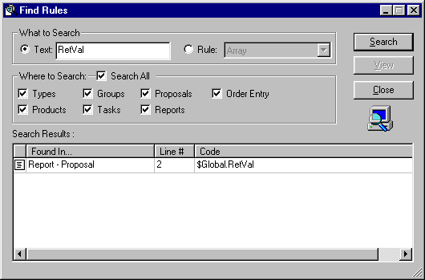

To search for all occurrences of a specific rule, click the radio button next to the Rule: field and select the rule to look for from the drop-down list.

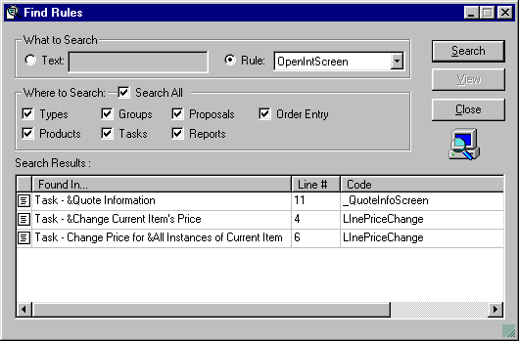

The Where to Search section allows you to limit your search to one or more subsystems.

To jump right to the code referenced in the Search Results box, simply double-click on that line in the Search Results window, or select the line and click the View button.

Logger
Logger is a utility that runs in the background in IFS Sales Configurator and logs each action that is taking place by the rules defined in IFS Sales Configurator Workshop. Logger can be turned on and off with a checkmark control at the bottom of the Tools menu. Logger functions can be controlled by right-clicking on the System Tray icon in Windows. You can Clear the log, Show the log in a window, or designate a file to store the log.

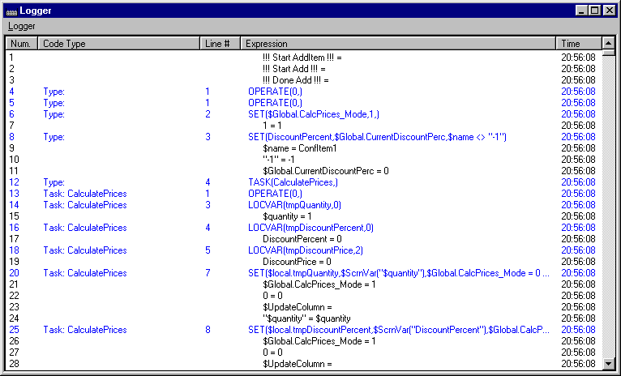

To install logger, download the file from Exactnet to any directory. Double-click the xmslog.exe file to initiate Logger. Once initiated, every time you start IFS Sales Configurator, Logger will start in the System Tray.

Variable Checker
Allows you to view and change Global variables and variables from Products in both the Options list and Bill of Materials (Conf).

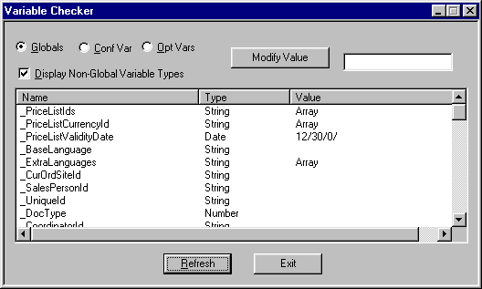

To modify a variable value, select the variable from the list and enter the new value in the edit field in the upper right corner, then click the Modify Value button.

IFS Sales Configurator remains fully functional in the background, so you can move it out of the way, or minimize it, to perform an action. When you return to Variable Checker, click the Refresh button to see the results of the action.

To install Variable Checker, download the VarCheck.dll file to the IFS Sales Configurator directory. A Variable Checker tool will be available at the bottom of the Tools menu.

PART II

Lesson 6: Baseline Rules distributed to all new installations

Pricing
Baseline pricing rules provide a sophisticated solution to virtually all pricing scenarios involving the routine inserting, deletion, and update of sales items in a configuration. These should not be modified except by an experienced (and brave) programmer.

Option Dependencies
This simple set of rules allows the user to address behavior issues among options. These rules are fired at the Insert and Delete tabs of special purpose groups in the Option Dependencies group category.

Order Validation
These rules check for “Placeholders” in the configuration and prevent the user from saving an incomplete order.

File Tasks
Examples of how to output data to files and read data back in from files.

Order Tasks
Samples of how to capture data with internal screens and use that data to populate data fields in output documents.

Pricing Tasks
The How To database contains generic pricing rules which can be used in an application not involving integration with IFS. Does not deal with multiple locations and currencies.

Proposal Tasks
Sample illustrations of how to populate data fields in proposal template documents.

Report Tasks
Sample illustrations of how to populate data fields in report template documents.

Lesson 7: How To Examples

The How To database contains several examples of “rule sets” that address specific application problems. Each of these sets contains a ReadMe rule which provides an overview of the solution in a remarks field.

How To examples will be covered for:
- Capacity Limits
- Filters
- Item Entry using the Keyboard
- Selecting Alternative Languages
- Multiple Quantity Adds
- Order File Creation
- Special Customer Request (SCR)
- Stand Alone Options

These examples represent one possible solution to each problem. Other solutions might work just as well. These are provided for illustrative purposes only.

If you find rules which will work as shown in these examples, perhaps with modest modifications, you can copy the rule statements from the How To database into another database by opening two instances of IFS Sales Configurator Workshop simultaneously. Select the lines of rules you want to copy using Ctrl + Shift, copy, and paste into the working database.

Capacity Limits

Whenever configurable options are constrained by a capacity variable, restrict the addition of other options to the configuration which might overload available capacity as follows:

- Create a special purposes group whose members include options that provide available capacity. Name this group something like "HorsepowerAvailable", or "BoardSlotsAvailable," or whatever is appropriate.

- Select as members of this group those options for which the capacity measurement provides the constraint as a variable.

In this example, several truck chassis are made members of this group. Each of these chassis has a horsepower rating which is reflected in the horsepower variable (named HP) for that chassis. This horsepower rating limits the number of other "horsepower-using" options which can go into the configuration.

Product Belongs
Name | Description
CHAS_3 | F650 Ford/190 HP/Automatic/4x2
CHAS_4 | F650 Ford/190 HP/Manual/4x2
CHAS_5 | L7501 Sterling/190HP/Automatic/4x2
CHAS_6 | L7501 Sterling/190HP/Manual/4x2
CHAS_9 | L7501 Sterling/250 HP/Manual/4x2 (Not Used)
CHAS_10 | L7501 Sterling/275 HP/Automatic/4x2

- Create a variable for the capacity constraint at the Generic Product Type level. For this example, the variable is HP = Horsepower.

- Write insert and delete rules to update the HP variable of the associated Main Item each time an item which ADDS capacity is added to or deleted from a configuration.

Insert Rules
Operate | Always
 | Set | $belong.HP | HP

Delete Rules
Operate | Always
 | Set | $belong.HP | 0

- Create another special purposes group containing as members those options which USE UP the available capacity. Name this group something like "HorsepowerConsumed", or "SlotsConsumed" or whatever is appropriate.

Each of the members of this group also has a horsepower rating reflected in its horsepower variable (variable name = HP).

Product Belongs
Name | Description
3004B | Blower-holmes 1020 4500cfm 16"hg
3005 | Blower-holmes HR80/42/15" 3150cfm
3006 | Blower-roots 824rcs/16" 3650cfm
3007 | Blower-roots 824rcs/18" 3500cfm
5000 | 40 @ 2500 psi w/accumulator
5001 | 60 @ 2000 psi system
5004 | 100 @ 2000 psi
I3010 | Blower (Std) 616
I3030 | Blower(Std) 624
I3030A | 624 blower in lieu of 616
I5000 | (Std) water pump 40gpm @ 2500psi
I5000B | Water pump 80gpm @ 2000psi

Whenever a member of this group is inserted into a configuration, it triggers the following rules, which deduct from the available horsepower of the associated Main Item ( $belong.HP) and reject the item if its addition will take available horsepower below zero.

Insert Rules
Operate | Always
 | Define Local Var | HP_start | Number
 | Set | $Local.HP_start | $belong.HP
 | Set | $belong.HP | $belong.HP - HP
 | Message | "Remaining HP available is" + $CStr($belong.HP )
 | Define Local Var | HP_flag | Number
 | Set | $Local.HP_flag | 1 | $belong.HP < 0
 | Message | "HP use exceeds HP capacity of chassis. Make another selection" | $Local.HP_flag = 1
 | Set | $belong.HP | $Local.HP_start | $Local.HP_flag = 1
 | Reject Item | $Local.HP_flag = 1

When one of these items is deleted from a configuration, its horsepower is added back into the available horsepower total through this delete rule:

Delete Rules
Operate | Always
 | Set | $belong.HP | $belong.HP + HP

Filter
Use the filter rule to control sort order of items in reports or proposals.

The default sort order of items in reports or proposals is the option ID number, which means that the last item added to a configuration is the last item printed. If some other sequence is desired, this can be governed by entering filter rules which run prior to setting values to the data fields in the report or proposal table.

This example demonstrates how to use two system variables ($belong and $name) plus one user-defined product variable (SortSeq) to govern sort order.

- The first step is to create a configuration variable named SortSeq at the Generic product type.

- Edit the user profile to display a column headed Sort Sequence in the configurator. Display the SortSeq variable in this column.

- Write the rule as a task named “ProposalSpecsSorted”, or something similar. Call the task from the Proposal, Order Entry, or Report Generator subsystem as needed.

The user can force items to appear at the head of the sort list by entering either alpha or numeric values to the SortSeq column in the Configurator. If nothing is entered in the SortSeq column, items print in part number sequence under each Main Item.

Operate | BOM
 | Remark | Sorts items in BOM based on main item, SortSeq variable, and $name.
 | Filter | "All" | BOM
 | Order | "All" | 1 | $belong | Ascending
 | Order | "All" | 2 | SortSeq | Descending
 | Order | "All" | 3 | $name | Ascending
 | Define Local Var | filterID | Identifier
Operate | While | $local.filterID <> 0
 | Document | $local.filterID.ProposalSpec |  | $CurrentBOMID <> $CurrentBOMID.$belong
 | Set | $local.filterID | $NextFilterID("All", $local.filterID)

Keyboard Versus Drag & Drop Item Entry

Keyboard entry of part numbers to a configuration: Some users prefer to key part numbers directly into a configuration rather than using the traditional drag & drop approach. Spare parts orders also can be created with this approach. This is very handy when the user needs to simply key in a list of parts for a spares order.

- Create two new Global Variables:

$Global.iKeyboardItemEntry_EnterPN: This will retain the value of a part number entered on an internal screen.

$Global.brKeyboardItemEntry_AddMultipleQty: This will retain a setting which allows the user to enter multiple part numbers without having to manually reopen the internal screen.

- Create an HTM page for the internal screen. See the SCR subsystem in this database for the screen named EnterPartNumber.

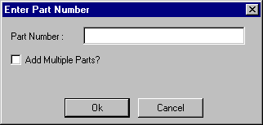

- Set up the following tasks as Tools:

KeyboardItemEntry: This will allow entry of individual part numbers. If items already exist in a configuration, the currently active Main Item will determine the availability of option items. If the user starts with a blank screen to the right (nothing yet selected), then multiple Main Items and options can be entered. The most recently entered Main Item controls availability of any options entered immediately afterwards.

OpenIntScreen | Enter_Part_Number | $Global.RetVal
Exit | $Global.RetVal="Cancel"
Attach | $GetOptionID($Global.Enter_Part_Number) | As New | Option | $GetOptionID($Global.Enter_Part_Number)>0 AND $IsAvailable($Global.Enter_Part_Number)=1
Message | "Part Number " + $Upper($Global.Enter_Part_Number) + " cannot be found." | $GetOptionID($Global.Enter_Part_Number)=0
Exit | $GetOptionID($Global.Enter_Part_Number)=0 AND $Global.AddMultipleParts <> 1
Message | "Part Number " + $Upper($Global.Enter_Part_Number) + " is not available to be added to the current Mainframe." + $Char(13) + $Char(13) + "Select the correct Mainframe on the right side, or add " + $Upper($Global.Enter_Part_Number) + " as a Spare Part." | $IsAvailable($Global.Enter_Part_Number)=0
Set | $Global.Enter_Part_Number | ""
Set | $Global.AddMultipleParts | 0 | $Global.RetVal="Cancel"
Operate | Always
Call Task | EnterPartNumber | $Global.AddMultipleParts = 1

KeyboardSparePartsItemEntry: Allows entry of spare parts. It automatically adds a Spare Parts Main item ($name = -1) and makes anything available to this Main Item.

Operate | Always
 | OpenIntScreen | Enter_Part_NumberSP | $Global.RetVal
 | Exit | $Global.RetVal="Cancel"
Operate | Always | $GetOptionID($Global.Enter_Part_Number)=0
 | Message | "Part Number " + $Upper($Global.Enter_Part_Number) + " cannot be found."
 | Exit
Operate | Always
 | Attach | "-1" | As New | Option | $GetConfID("-1")=0
 | Set | $CurrentMainItem | $GetConfID("-1")
 | Available | $GetOptionID($Global.Enter_Part_Number)
 | Attach | $GetOptionID($Global.Enter_Part_Number) | As New | Option
 | Set | $Global.AddMultipleParts | 0 | $Global.RetVal="Cancel"
 | Set | $Global.Enter_Part_Number | ""
Operate | Always
 | Call Task | EnterPartNumberSP | $Global.AddMultipleParts = 1

Selecting Alternative Languages

Users of the IFS Sales Configurator sometimes need to display on the Configuration screen and in proposals or reports line item descriptions in different languages. This document explains the steps involved in implementing multiple language solutions.

- Create the following global variables:

  - $Global.LangIndex (number)
  - $Global.ReturnVal (number)
  - $Global.RestoreDefaultLang (number)

Note:
- IFS implementations will already have a Global variable named _ExtraDescriptions. This is a string array populated with any alternative languages brought over through the Synchronization program.

- Create a product variable named AlternateLang.

- Change User Profile to use this variable to display in the Description column.

- Create an Internal Screen named LangQuestion. See Screen Design subsystem in HowTo database for details.

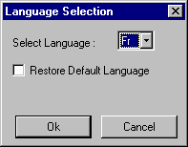

Language Selection Screen
Attributes
Name | Type | Description | Display Picture | Disable If... | Hint
Language | Combo | Select Language | N/A
RestoreDefault | Checkbox | Restore Default Language | N/A

Input
Name | Type | Options | Default | Display | Condition | Message
Language | Combo | $Global._ExtraLanguages
RestoreDefault | Checkbox |  | OFF

Output
Name | Type | Variable | Output to...
Language | Combo |  | $Global.LangIndex
RestoreDefault | Checkbox | N/A | $Global.RestoreDefaultLang

Setting the language when inserting items to a configuration:
Write Insert rules at the Generic Product Type that set the AlternativeLang with a selected alternative language equivalent, or with the default language if no alternative exists for the part being inserted:

Set | AlternateLang | _ExtraDescriptions[$Global.LangIndex] | $Global.RestoreDefaultLang <> 1
Set | AlternateLang | $desc | AlternateLang = ""

Write two tools, as described below, that allow the user to specify the language to use at the next insert action, and allow the user to reset the language used on all items in the configuration.

Select Language Tool:

Operate | Always
 | OpenIntScreen | LangQuestion | $Global.ReturnVal
 | Exit | $Global.ReturnVal = 0
 | Set | $Global.Language | ""

Change Selected Language Tool:

Operate | Always
 | Remark | Use this Tool to change the selected language for items in the configuration of for newly selected items. Also used to restore default language.
 | OpenIntScreen | LangQuestion
 | Set | $Global.LangIndex | "" | $Global.RestoreDefaultLang <> 0
Operate | BOM
 | Set | $CurrentBOMID.AlternateLang | $CurrentBOMID._ExtraDescriptions  [$Global.LangIndex] | $CurrentBOMID._ExtraDescriptions  [$Global.LangIndex] <> ""
 | Set | $CurrentBOMID.AlternateLang | $CurrentBOMID.$Desc | $Global.RestoreDefaultLang <> 0

Using the alternative language in output documents:

Edit appropriate commands in the Proposal, Report, or Order Entry templates to use AlternateLang as the description variable.

Multiple Qty Adds
The folllowing method can be used to enable attachment of a number of items.

- Add a String array variable called "QuanArr" to the Main-Item product type
- Add the below SetOptionQuantities Task in the Task sub-system
- Call this Task in the Generic Product Type Insert rule

The IFS Sales Configurator Workshop user will have to type for each Main Item the $name of the product of which the quantity needs to be changed, and the number of items to be added, separated by the '|' sign. (Each array entry will have to have this pair of strings.)

This example shows the QuanArray array of a given Main Item. The system will now change the quantity of Item1 to 5, Item2 to 3 etc. when they are added to the configuration under the Main Item that has this array variable value.
1 Item1|5
2 Item2|3
3 Item3|4

SetOptionQuantities Task
Operate | Always
 | Define Local Var | leftStr | String
 | Define Local Var | rightStr | String
 | Define Local Var | arrCounter | Number | 1
Operate | While | $local.arrCounter <= $ArrayEntries($CurrentMainItem.QuanArr)
 | Set | $local.leftStr | $Left($CurrentMainItem.QuanArr[$local.arrCounter], $Find("|",$CurrentMainItem.QuanArr[$local.arrCounter],1) - 1)
 | Break | $local.leftStr = $name
 | Set | $local.arrCounter | $local.arrCounter + 1
Operate | Always
 | Exit | $local.leftStr. <> $name
 | Set | $local.rightStr | $Right($CurrentMainItem.QuanArr[$local.arrCounter], $Len($CurrentMainItem.QuanArr[$local.arrCounter]) - $Find("|",$CurrentMainItem.QuanArr[$local.arrCounter],1))
 | Set | $quantity | $CInt($local.rightStr)

Order File Creation
Occasionally, a customer wants a simple text file created with selected information from a configured order.

These rules were developed for a customer who also wanted each file identified with a unique number consisting of the dealer ID number and a sequence number. This concatenated order number was to be used to name the file and also needed to be within the file.

A total of five tasks were needed: three tools which could be called independently by the user, and two routines.

The following Global Variables are needed for these tasks:

$Global.OrderFileHandle
$Global.ORD_OrderNum
$Global.ReturnValue
$Global.ORD_SeqNum
$Global.ORD_OrderNum
$Global.ORD_DlrNum

The HT_SetOrderNumber tool specifies the dealer number and sets the starting number of the series.

This task creates in the IFS Sales Configurator directory a file named OrdNum.Dat which contains the dealer ID and the latest assigned number in the series.

The HT_IdthisOrder tool calls the task “HT_GetOrderNumber”, which opens the OrdNum.Dat file, reads the dealer number and last-used order number, and builds a unique number for the order. This number is used to set the $Global.ORD_OrderNum.

Next, the HT_SetNewOrderNumber task is called to update the OrdNum.Dat file with the latest order number used.

The HT_CreateOutputFile tool creates a text file named for the order number. Data fields output to this file are determined according to the customer’s needs.

See the How To Database rules for details.

Special Customer Request (SCR) Parts and IFS Integration

Special customer requests are used to add sales options to a configuration when there is no associated part number for that option in IFS. Before this process can take place, a number of things must be done in both Workshop and within IFS.

In IFS

- Engineering must add a part to the system called “SCR” with description “SPECIAL CUSTOMER REQUEST”.

In Workshop

- In the Product Types subsystem, create a Special Customer Request product type under Optionals.
- While selecting this new product type, select the Rules tab, then select the Insert tab and call the task named “Add SCR”. (See the following rule grid to write this task.)
- While selecting this new product type, select the Variables tab and create the following three new Configuration variables:
- SCR_ price (currency variable)
- SCR_name (string variable)
- SCR_description(string variable)
- While selecting the top level Product Type in the Product Types subsystem, create the following new global variables:
- $Global.SCR_Price (currency variable)
- $Global.SCR_Name (string variable)
- $Global.SCR_Desc (string variable)
- In the Products subsystem, under the new Special Customer Request product type, add an item with name “SCR” and the description “SPECIAL CUSTOMER REQUEST”. Alternatively, import this SCR part from IFS through the synchronization program.
- While still in the Products subsystem, select the new SCR part, and click on the Available to Groups tab. Use Show All to open all Main Item groups. Make the SCR part available to all Main Item groups.
- In the Configurator subsystem, create a new option folder titled Special Customer Request. Drag the new SCR part into this folder.
- In User Profiles, add the two new variables (SCR_name and SCR_description) as ListView options.
- In the Tasks subsystem, create a new task named “AddScr” as follows (This is the task called on the Insert tab of the Special Customer Request product type.)

AddScr Task
Operate | Always
 | Set | $Global.SCR_Price | LinePrice
 | Set | $Global.SCR_Name | SCR_Name
 | Set | $Global.SCR_Desc | SCR_Description
 | Call Task | ValidateSCR
 | Exit | $Global.RetVal = 0
 | Set | SCR_Description | $Global.SCR_Desc
 | Set | SCR_Name | $Global.SCR_Name
 | Set | LinePrice | $Global.SCR_Price

A task named “ValidateSCR” is called from inside the “AddScr” task. This task does two things:
- Opens an internal screen which prompts the user for name, description, and price of the new SCR item.
- Validates the length of the description to make sure it does not exceed 35 characters.

ValidateSCR Task
Operate | Always
 | OpenIntScreen | SCR | $Global.RetVal
 | Exit | $Global.RetVal = 0
Operate | While | $Len($Global.SCR_Desc) > 35
 | Message | "SCR Description is longer then 35 characters"
 | OpenIntScreen | SCR | $Global.RetVal
 | Exit | $Global.RetVal = 0

- Create the internal screen named “SCR” as follows:
  - Create an HTML document with three Text form fields named, respectively, “Name”, “Description” and “Price”. Save it in the SCR subdirectory under workshop.
  - In the Screen Generator subsystem, create a new internal screen named SCR. Link it to the HTML document SCR.HTML in the SCR subdirectory.
  - Specify in the Input and Output tabs for this screen the following values:
- Name field: $Global.SCR_name
- Description field: $Global.SCR_description
- Price field: $Global.SCR_price

Once all the pieces are in place, the following occurs when an SCR part is added to a configuration:

- A SCR option is added to the order configuration.
- A part name, description, and price are entered into a pop-up window triggered by the SCR addition.
- The order is saved and the trn file is imported into IFS.
- The Engineering department decides whether this option is needed and, if so, creates a part number for the item.
- Engineering creates a change order. The newly created part number is exported to ESS Workshop and properly entered into the system. A new data version is generated.
- The IFS Sales Configurator user is notified of the change and opens the order involving the SCR in the new data version. The user deletes the SCR part and inserts the newly created part number in its place.
- The order is once again saved and imported into IFS. The newly created part now is handled in the same way as any other “change” to the existing order in IFS.

Stand Alone Options

A customer wanted to show a warning if an item already existed in a configuration and reject the addition of a second instance of that item. This was to be done for over one hundred option items which had nothing in common functionally and were not candidates for the traditional option group approach.

The same customer also had in their catalog a number of items which could occur more than once in a configuration, but shared no common characteristics that would support putting them into option groups. They wanted to warn the user if an item already existed, but still allow them to add another instance.

Both of these requirements were met by creating two special purpose groups. One for "StandAlone Single" items and one for "StandAloneMultiples". Items which should never exist more than once in a configuration were made members of the "StandAloneSingle" group.

Items which could exist more than once were made members of the "StandAlongMultiples" group. Rules were written at the Insert tab for these two groups, to warn the user if the item already existed in the configuration and, in the case of the StandAloneSingles, reject any addition to the configuration.

- Create a global variable: $Global.StandAloneExists.
- Write the following rules at the Insert level for each group.
- Select items as belonging to the appropriate group.
- Make sure that any options selected as members of these groups are NOT in any other option groups.

Rules for the StandAloneSingle Group
Operate | Always
 | Set | $Global.StandAloneExists | 0 |  |  | Clears the global variable "flag"
 | Set | $Global.StandAloneExists | 1 | $GetConfID($name ).$name = $name |  | Sets global flag to one if selected item is already in the configuration
 | Message | "This item already is in the configuration. Only one allowed" | $Global.StandAloneExists = 1 | Warns the user that the item already exists
 | Reject Item | $Global.StandAloneExists = 1 | Rejects the item.

Rules for the StandAloneMultiples Group

Operate | Always
 | Set | $Global.StandAloneExists | 0 |  |  | Clears the global variable "flag"
 | Set | $Global.StandAloneExists | 1 | $GetConfID($name ).$name = $name |  | Sets global flag to one if selected item is already in the configuration
 | Message | "This item already is in the configuration. This will add another one. Delete the extra if necessary" | $Global.StandAloneExists = 1 | Warns the user that the item already exists

PART III

Lesson 8: Screen Design Section
OBJECTIVE: Understand how to name screens, link them to HTML files, specify data field names, specify default value for screen data fields when first opened, and specify where to store output values when screen is closed.

The Screen Generator subsystem enables you to facilitate the configuration and proposal process for the IFS Sales Configurator user.

Using the Screen Generator subsystem, you can link the screens you create in an HTML editor to your database. These same screens are then displayed as dialog boxes in which IFS Sales Configurator users enter data for a configuration.

As the IFS Sales Configurator Workshop administrator, you determine when the screen is launched by writing a rule that invokes it. For example, you might set a screen to launch after a Main Item is selected so the user can select options that are available with a particular Main Item. You might also choose to launch one when a configuration is complete so new information can be captured for use in a file which is sent to another system.

Note:
- You can link a task to a screen event, such as Exit and Change.

Determine what data needs to be captured or what variables need to be reset by prompting the user. Use the Open Internal Screen command, from a rule statement in a routine or a tool, as appropriate. Create an HTML page with embedded form fields which will prompt for the desired information. These form fields could be text fields, combo boxes, scrolling text boxes, check boxes, or radio buttons.

Screen Generation process

You begin the screen generation process by designing the screen layout as an HTML file. Using an HTML editor, you create a screen with the necessary controls as part of the HTML file. Once you design the layout, IFS Sales Configurator Workshop associates the information from the HTML file as an object that becomes part of the configuration version.

Note:
- The HTML pages you create display as Microsoft Windows dialog boxes in IFS Sales Configurator.

GUI controls
IFS Sales Configurator Workshop supports five types of GUI (Graphical User Interface) controls on a screen. These controls include: edit fields, combo boxes, scrolling text boxes, radio buttons, and check boxes.

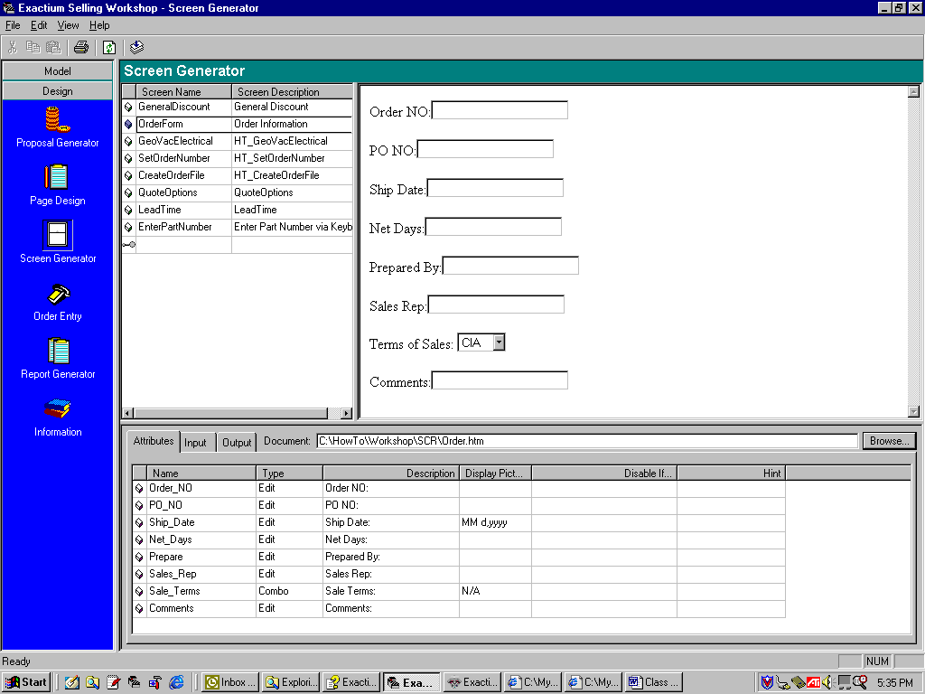

Use the Attributes tab to specify the names of the data fields the user will see when the screen displays. Also use this tab to specify display pictures and to disable fields for data input, if necessary. (Disable by entering a “1” in the Disable If… column).

Use the Input tab to specify variables to display when opening the screen. These can be left blank, if appropriate. If you want to display an existing variable for the user to see before entering new data, display that variable name in this field.

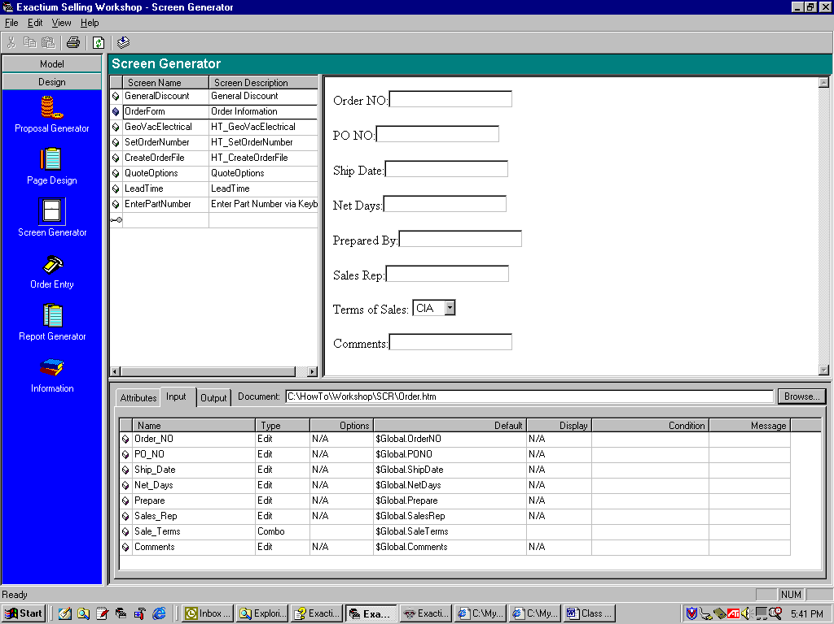

If the form field is a combo box, the selection values can be coded into the combo box field within the HTML document, can be entered in a Global Array Variable, or can be the belong items of a special purpose group. Display group names by entering $Option.$InGroup(“GroupName”) in the Options column.

Use the Output tab to specify where to store values entered in the data fields.

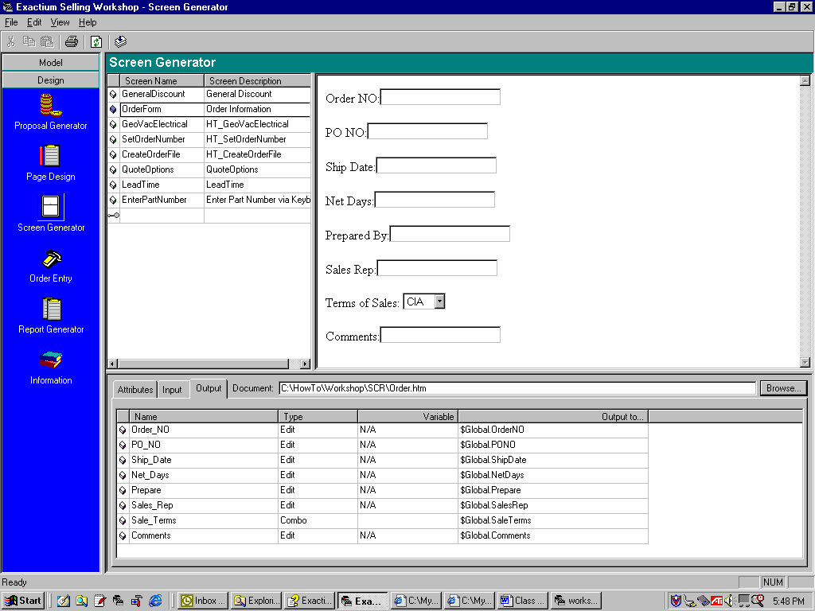

Lesson 9: Page Design Section
OBJECTIVE: Understand how to name page design sections, link them to HTML documents, specify formatting of data fields, and set values to data fields.

Use the Page Design subsystem to create links to HTML page documents and provide a mechanism for updating date fields in the pages. The individual pages can then be used as sections in proposals, reports, or order entry forms.

First step in generating an output document through the IFS Sales Configurator is to design the document layout. Break the design into sections, such as Header Information, Body (which may be a table), Summary Information, Order Acknowledgement, etc. Calling for a page section created in the page design subsystem will generate each of these document sections.

Specifying the HTML page location

To specify the path of your HTML page:

- In the selection bar, click the Page Design subsystem icon.
- In the left pane, select the appropriate section.
- In the right pane, click the Attributes tab.
- Click the Browse… button to locate your saved HTML file. The Open dialog box appears. Locate and select the file that you want to link to the section. When you select the file, the selected HTML page appears in the Preview window of the Open dialog box.
- You have the following options:
  - If the HTML page in the Preview pane is correct, then click the Open button to link the page.The file path appears in the Document field of the Attributes tab in Workshop, and the HTML page appears in the lower pane.
  - If the HTML page needs to be changed, click the Edit button in the Open dialog box. The page automatically opens in your HTML editor where you can make the necessary changes and resave.
  - If you want to create a new HTML page, click the Create New button of the Open dialog box. The New HTML Document dialog box appears. Enter a name, and click OK. The new HTML page is added to the list of available pages. When you click the Edit button, your HTML editor automatically opens.

Note:
- After you have linked the HTML page to a section in IFS Sales Configurator Workshop, you can view the section in the lower pane by selecting the section in the tree structure.
- You can edit your section by selecting Edit from the Workshop menu bar, and then selecting Edit Section Document from the pull-down menu. If you are proficient in HTML source code editing, you can access that code by right clicking in the displayed document and selecting “View Source”. Edit the source and then select Refresh.

Defining section fields

Using the Fields tab, you define the fields that appear in your section. These field names are created in the HTML document by entering the field name in square brackets with a # sign before the field name. Example: [#FieldNameOne] in the HTML document would appear in the Fields tab for that document.

Use the Fields tab to specify the type of field used, the database association with that field, and whether or not the field has a picture (mask) associated with it.

To define a field:
- In the selection bar, click the Page Design subsystem icon.
- In the left pane, select the appropriate section.
- In the right pane, click the Fields tab.

For every line of your HTML page that contains the template tags [#field_name], the following defaults are automatically entered:

- The Name field contains the variable name you typed between the brackets in your HTML page.

- The default Type field is String. This must be changed as appropriate for any data filed which contains a numerical, currency, or date value.

- The Display Picture field is only applicable for number and date.

- If the Type is “Number”, double-click in this field and select the folder icon to see the Number Picture dialog box. Then select how you would like the number represented, including negatives, decimal placement, and digits after the decimal point.

- If the Type is “Date”, double-click in the field and select the folder icon to see the Date and Time Picture dialog box. Then specify how to display date and time.

- The default Expression field is blank. The Expression field is the variable you choose to populate the designated HTML field if you will use the Auto action when calling the section. Leave the Expression field blank and assign the field values with the Set statement in the rules that call this section if you will use the Template action when calling the section.

- Double-click in the Type drop-down list box to change the type variable. For example, if you have a cost field, the type should be Currency.
APPENDIX A
ASCII Codes

0 | Null | 59 | ; | 94 | ^ | 160 | Space | 195 | Â | 230 | æ
7 | Bell | 60 | < | 95 | _ | 161 | ¡ | 196 | Ä | 231 | ç
8 | Back Space | 61 | = | 96 | ` | 162 | ¢ | 197 | Å | 232 | è
9 | Tab | 62 | > | 97 | a | 163 | £ | 198 | Æ | 233 | é
10 | Line Feed | 63 | ? | 98 | b | 164 | ¤ | 199 | Ç | 234 | ê
13 | Carriage Ret | 64 | @ | 99 | c | 165 | ¥ | 200 | È | 235 | ë
26 | End of File | 65 | A | 100 | d | 166 | ¦ | 201 | É | 236 | ì
27 | Escape | 66 | B | 101 | e | 167 | § | 202 | Ê | 237 | í
32 | Space | 67 | C | 102 | f | 168 | ¨ | 203 | Ë | 238 | î
33 | ! | 68 | D | 103 | g | 169 | © | 204 | Ì | 239 | ï
34 | " | 69 | E | 104 | h | 170 | ª | 205 | Í | 240 | ð
35 | # | 70 | F | 105 | i | 171 | " | 206 | Î | 241 | ñ
36 | $ | 71 | G | 106 | j | 172 | ¬ | 207 | Ï | 242 | ò
37 | % | 72 | H | 107 | k | 173 |  | 208 | Ð | 243 | ó
38 | & | 73 | I | 108 | l | 174 | ® | 209 | Ñ | 244 | ô
39 | ' | 74 | J | 109 | m | 175 | ¯ | 210 | Ò | 245 | õ
40 | ( | 75 | K | 110 | n | 176 | ° | 211 | Ó | 246 | ö
41 | ) | 76 | L | 111 | o | 177 | ± | 212 | Ô | 247 | ÷
42 | * | 77 | M | 112 | p | 178 | ² | 213 | Õ | 248 | ø
43 | + | 78 | N | 113 | q | 179 | ³ | 214 | Ö | 249 | ù
44 | , | 79 | O | 114 | r | 180 | ´ | 215 | × | 250 | ú
45 | - | 80 | P | 115 | s | 181 | µ | 216 | Ø | 251 | û
46 | . | 81 | Q | 116 | t | 182 | ¶ | 217 | Ù | 252 | ü
47 | / | 82 | R | 117 | u | 183 | · | 218 | Ú | 253 | ý
49 | 1 | 83 | S | 118 | v | 184 | ¸ | 219 | Û | 254 | þ
48 | 0 | 84 | T | 119 | w | 185 | ¹ | 220 | Ü | 255 | ÿ
50 | 2 | 85 | U | 120 | x | 186 | º | 221 | Ý
51 | 3 | 86 | V | 121 | y | 187 | " | 222 | Þ
52 | 4 | 87 | W | 122 | z | 188 | ¼ | 223 | ß
53 | 5 | 88 | X | 123 | { | 189 | ½ | 224 | à
54 | 6 | 89 | Y | 124 | I | 190 | ¾ | 225 | á
55 | 7 | 90 | Z | 125 | } | 191 | ¿ | 226 | â
56 | 8 | 91 | [ | 126 | ~ | 192 | À | 227 | ã
57 | 9 | 92 | \ | 145 | ' | 193 | Á | 228 | ä
58 | : | 93 | ] | 146 | ' | 194 | Â | 229 | å
APPENDIX B
Exercises

Exercise One: Using the Rules grid
In this exercise, we will get familiar with the Rules grid. The Rules grid resembles a spreadsheet with rows and columns, and column headings to indicate the column's function. The column headings change depending on which rule you are writing, and always reflect the arguments for the selected row.

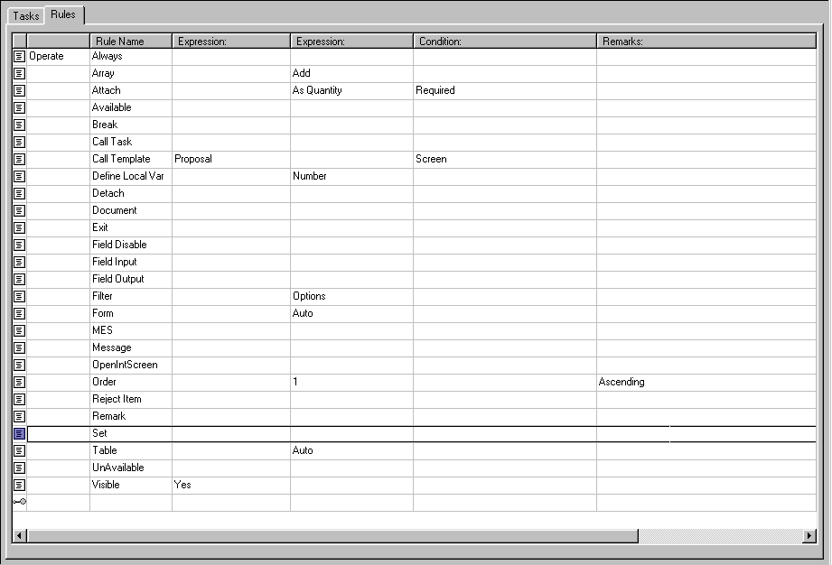

Let's create a task to set the Extended Price to the Base Price times the Quantity for each item in the configuration.
- Click on the Tasks subsystem icon in the Selection Bar.
- In the left pane, click the Tasks folder.
- In the right pane, click the Tasks tab.
- Locate the New Record icon in the last row of the grid and double-click in the Name column.
- Enter "CalcExtPrice". Then enter "Calculate Extended Price" for the description.
- Click on the Calculate Extended Price task under the Tasks folder in the left pane.
- Click the Rules tab in the right pane.
- The Rules tab will contain a rule grid with the first Operate rule already defined. This is because all rules must be written after an Operate rule. You can change the type of the first Operate rule to fit your needs. For this example, change it to Operate BOM.
- Operate rules are always in the leftmost column to visually distinguish blocks of code.
- To begin writing rules, double-click in the Rule Name column in the New Record row. Select the Set rule.
- Notice that the column headings change to reflect the arguments for the Set rule.
- Double-click the first Expression column and click the folder button at the right side of the cell.
- The Expression dialog box opens, which allows you to write the expression in a larger field, change the font, or open the Parameters dialog box to select a variable.
- Type "$CurrentBOMID", then a period (the dot operator), then "ExtendedPrice".
- Click OK to close the Expression box and return your expression to the rule cell.
- Complete the second Expression cell in the same manner so the cell reads "$CurrentBOMID._BasePrice * $CurrentBOMID.$quantity"
- You can type in the expression directly into the cell or the Expression box.
- Leave the condition argument blank since we want to perform this calculation on all items in the BOM.
- Enter a comment in the Remarks column to describe what the task is doing.

Let's create another rule that makes products invisible both to the user and to documents generated from the BOM. There may be parts that are needed to be part of the configuration, but are not required to be seen by the user or output documents, such as bolts in a manufacturing implementation.

- First, we need to create a variable to store whether we want an item to be visible or not. Go to the Product Types subsystem and create a string variable called "_Show". Make sure to create this variable at the proper level so it will be inherited by all products.

- Now, we will decide which rule grid is appropriate for this rule. Remember that rules can be written in Groups, Product Types, Products, Tasks, Proposal Generator, Report Generator, and Order Entry. Select the subsystem where you would like to write the rule by clicking it in the Selection Bar.

- Under an Operate Always rule, write a Visible rule to make all items being inserted invisible if the value of their _Show variable is "No".
- Insert a Remark rule above the rule you wrote in step (c) to describe the purpose of the Visible rule.
Place cursor on Operate rule and press Insert key.

Now practice on your own with the following rules:
- Array
- Attach
- Available
- Call Task
- Call Template
- Define Local Var
- Filter
- Form
- Message
- OpenIntScreen
- Remark

Exercise Two: Using the Parameters dialog box
In this exercise, we will use the Parameters dialog box to directly select elements to add to an expression without having to type them in manually.

Let's create the same loop as the previous exercise, using the Parameters dialog box instead of typing the expression in directly.

- Click on the Tasks subsystem icon in the Selection Bar.
- Click on the Calculate Extended Price task under the Tasks folder in the left pane.
- Click the Rules tab in the right pane.
- Select the second row by clicking on it.
- Hold down the Shift key and click the last row.
- All rows between the second and last row are selected.
- Press the Delete key, or right-click in the selection and choose Delete.
- All the rules from the previous example are deleted.

- Double-click in the Rule Name column in the New Record row. Select the Set rule.
- Double-click the first Expression column and click the folder button at the right side of the cell.
- Click on the Parameters… button to launch the Parameters dialog box, then click on the Globals tab.
- Scroll down to $CurrentBOMID and click on it once to select it, then click OK.
- $CurrentBOMID is entered into the Expression box
- Position the cursor at the end of $CurrentBOMID and type a period (the dot operator).
- Click the Parameter…button again and select the Variables tab.
- In the Category drop down list, select Pricing.
- Double-click the ExtendedPrice variable.
- Double-clicking a row in the Parameters box is the same as selecting the row and clicking OK.
- Click OK to close the Expression box and return your expression to the rule cell.
- Complete the second Expression cell in the same manner so the cell reads "$CurrentBOMID._BasePrice * $CurrentBOMID.$quantity"
- _BasePrice is in the Pricing category of the variables tab.
- $quantity is in the System Defined category of the variables tab.

Exercise Three: Using $OPTION and $CONF
In this exercise, we will begin to explore the power of the system objects $OPTION and $CONF.

First, we will use $OPTION to make items in a group unavailable to a Configurable item based on the value of a variable. Since we are adding a condition, we will create the set of rules in the Product Types subsystem for all Configurable items upon being inserted into the configuration. Even though the rule will be run as each Configurable item is added to the configuration, the condition statement will prevent it from running on items that do not have the value we specify in the variable we specify.

- First, go to the Product Types subsystem.
- Expand folders in the left pane to find the Configurables folder and click it to select it.
- In the right pane, click the Rules tab and notice the three sub tabs for Insert, Delete, and Update. Since we want our rules to fire when a Configurable item is added, we will write our block of rules on the Insert tab.
- Notice that other insert rules have already been written.

- To apply a condition to the entire block of rules, write an Operate Always loop in the New Record row, and enter the following condition: $CurrentConfItem._PriceGroup = "TypeEInvalid"
- All rules up to the next Operate rule will only be executed if the item being inserted has "TypeEInvalid" as the value of it's _PriceGroup variable.
- Write an UnAvailable rule to make the Belong Items of the TypeEOptions group unavailable to this Configurable item.
- Choose UnAvailable from the Rule Name list.
- In the Expression column, type the following expression: $OPTION.$GroupItems("TypeEOptions")
- All items in the Options list that are Belong Items in the specified group will be made unavailable to the Configurable item being inserted.
OR

Now, we'll use $CONF to remove any item with a zero price from the configuration.

We will provide this functionality to the user by creating the rules as a Tool that is available for the user to run from the Tools menu in IFS Sales Configurator.

- Go to the Tasks subsystem.
- Create a new task under the Pricing folder with the following information:
- Name: DetachNoCostItems
- Description: Detach No Cost Items
- Type: Tool
- Since the $CONF object operates on each product in the configuration, there is no need to create a loop to go through the BOM. We can accomplish the goal of our example with a single Detach rule. Create a Detach rule under the Operate Always rule with the following arguments:
- Expression: $CONF._BasePrice = 0

We can also use functions in conjunction with the $OPTION and $CONF objects. If, in the example above, we wanted to detach all the products that are in the Staging product type, you would use the expression: $CONF.$InType("Staging")

Exercise Four: Referencing the correct object with System Globals
In this exercise, we will determine the correct system global to use to reference a product.

The system globals that hold product identifiers can be for the Options List, which is the left side of IFS Sales Configurator, also called the catalog. They also can reference the configuration products, which is the right side of IFS Sales Configurator, or the Bill of Materials. The product identifying system globals are:

OPTION |  | CONF
- $CurrentOptionID |  | - $CurrentBOMID
- $CurrentOptionItem |  | - $CurrentConfItem
- $FirstOptionID |  | - $CurrentMainItem
- $LastOptionID |  | - $FirstConfID
 |  | - $LastConfID

Complete the following chart by entering the correct system global for referencing a product given the situation indicated.

You can imagine that you need to reference a variable for the product in a Set rule in the given situation (here we will double the price of the item to boost profits). The set rule would look like this:
Set | <<PRODUCT>>.Price | <<PRODUCT>>.Price * 2
You need to fill in the <<PRODUCT>> component for each situation.

Situation | System Global Product Identifier
- within an Operate BOM loop
- within an Operate Options loop
- within an Operate CMI loop
- within an Operate Always
- in a Group rule
- in a Product Type rule
- in a Product rule
- the selected Option
- the selected Configuration item
- the Configurable item associated with the selected Configuration item

Exercise Five: $ScrnVar
In this exercise, we are going to write a set of rules that will change the quantity of option items to match the quantity of the associated configurable item when the quantity of the associated configurable item is changed by the user. Here, the user has been given rights to edit the $Quantity field in his User Profile.

- Decide which rule grid is appropriate to write a rule that runs whenever any configurable item's quantity is updated.
- Begin rule writing in the New Record row with an Operate Always rule with the following condition: $UpdateColumn = "$quantity". This will prevent our rules from running if the user has edited any column other that Quantity.
- Now that we know the changed variable was $quantity, we need to see if the item that was changed is a configurable item. If the item is an option and not a configurable item, we don't want our rule to run. Add the condition that the item is a configurable item to the Operate condition expression using the AND operator.
- For our rule to run, we know that the quantity of a configurable item has been changed by the user.

All of our checking has been entered into the condition cell of the Operate rule, and now we are ready to write the rule that will actually do the work. We want to change the quantity of all option items to the same number as the new configurable item's quantity.

- Make a change that will make our rules run for each item associated with the current main item.
- Write a single rule to change the quantity of each item to the updated configurable item's quantity.
- The configurable item's quantity comes from the statement $ScrnVar("$quantity").

Exercise Six: Using Arrays
In this exercise, we will use a pair of arrays to store sales tax rates for different cities. The first array will contain the city names, the second will store the tax rates for those cities. First, we look up the customer's city in the city array, then use that element number to look up the tax rate in the second array.

To prepare, we need to create and populate the arrays.
- Create three global variables as follows:
- $Global.SalesTaxCity as string-array
- $Global.SalesTaxRate as number-array
- $Global.SalesTaxAmount as currency
- Enter the following data into the arrays:

Element | SalesTaxCity | SalesTaxRate
1 | Gothenburg | .09
2 | Stockholm | .11
3 | Malmo | .08
4 | Jonkoping | .09

Now we will create the code to look up the tax rate that will go into your pricing rules.

- Define a local variable to hold the loop ID of type number and initialize to zero.
- Define a local variable to store the number of elements in the array and initialize to the number of elements in the array. You can assume that both arrays will always have the same number of elements.
- Define a local variable as a flag to set if a match is found and set to "No".
- Create a While loop that will run as long as the loop ID is less than the number of array entries.
- Inside the While loop:
- increment the loop ID by one
- break out of the loop and set the found flag if the loop ID element of the SalesTaxCity array equals the variable $Global.Addr_City
- Now write an Operate Always rule block to set the tax amount. We will assume that any city not in the SalesTaxCity array will not have any sales tax.
- Set the tax amount to zero and break if the found flag was not set.
- Set the tax amount to $TotalPrice times the loop ID element of the SalesTaxRate array.

Exercise Seven: Complex String Expressions
In this exercise, we will create a complex string that will be used on a proposal document as the legal notice at the bottom of the page, "the fine print." The legal notice will include some standard text, and some that is applicable only if a certain product has been added to the configuration.

We will use the global variable _Notes to store the string.

- Decide which rule grid is appropriate to write a rule that runs whenever any proposal is created.
- Remember that the rule grid in the Proposal subsystem is different for each proposal that is defined. Do not plan to duplicate the rule you write for each proposal.
- Choose the appropriate Operate rule.
- Write a rule to store the following text in the global variable.
- "Unless specified otherwise, standard shipping method is FedEx economy (two-day service). This quotation is for solicitation purposes only and does not constitute an offer."
- Write another rule to add the following text if the ConfItem2 product has been included in the configuration. If the configuration does not include the ConfItem2 product, do not add this text to the global variable.
- "ConfItem2 requires professional installation services which are not included in this proposal."
- Now write code to add a statement to the global variable for the amount of the Annual Maintenance charge. If the total of the proposal is less than 50,000, then the annual maintenance charge is 1,000. If the total of the proposal is 50,000 or more, the annual maintenance charge is 1,750.

This completes the creation of our legal note. You would use the Page Design subsystem to add the note to your proposal.

Exercise Eight: Using Nested Loops
In this exercise, we are going to use a nested loop to determine how many option items have been added to each configurable item and display a message to the user for each.

To do this, we will create a loop and inside that loop we will call another task. Since there is no way to pass arguments between two tasks, we will use global variables to store values in one task that can then be accessed from the other task.

- Create two global variables:
- LoopProd - to store the ID of the current item in the first loop
- OptionCount - to store the number of option items found

The logic to achieve the desired results is outlined below. Enter the logic into tasks in IFS Sales Configurator Workshop syntax to mimic this logic.

- For every item in the Bill of Materials:
Set LoopProd to the ID of the current product
Set the pointer of the current configurable item to the ID of the current product
Call a task to count the option items if the current product is a Configurable item
Display a message similar to the following if the current product is a Configurable item

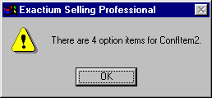

Clear the OptionCount variable so it is ready for the next item in the Bill of Materials

To count the option items for the current product, use this logic:

- Define a local variable to hold the count of items within this procedure and initialize it to zero
- For each item that belongs to the current configurable item:
Increment the local count variable by one if the item is an option item
- Set OptionCount to the value of the local count variable

